Psychology Internship
Training Manual
2017-2018

Copyright © 2017 University of Utah

Contents
I. DIRECT SERVICE AGREEMENT AND PLANNING YOUR SCHEDULE 1
A. Basic Formula for Targeting 1
B. Descriptions of Other Time Commitments 1
C. Required Hours and Activity Summary 3
D. Vacation Policy, Leave, & Holidays 4
E. “After Hours, Other” Hours 5
II. ELIGIBLE UCC PSYCHOLOGY PRIMARY SUPERVISORS 6
III. ADMINISTRATIVE ASSISTANCE 7
IV. FINANCIAL SUPPORT 8
V. PERSONAL DISCLOSURE POLICY FOR UCC TRAINEES 8
VI. PROGRAM AIMS, COMPETENCIES, AND TRAINING ELEMENTS 11
VII. EVALUATION 26
A. Evaluation Processes and Schedules 26
B. EVALUATION OF TRAINEE: COMPREHENSIVE EVALUATION SYSTEM 27
C. SUPERVISOR SKILLS EVALUATION FORM 28
D. THE COMPREHENSIVE EVALUATION OF STUDENT-TRAINEE COMPETENCE IN PROFESSIONAL TRAINING PROGRAMS 34
VIII. TRAINEE RIGHTS AND RESPONSIBILITIES AND DUE PROCESS PROCEDURES¹ 38
A. Trainee Review and Evaluation 39
B. Procedures for Responding to Inadequate Performance by a Trainee 38
C. Procedures to Advise and Assist Trainees who are not Performing at the Program's Expected Level of Competence 39
D. Problematic Behavior, Attitudes, or Characteristics 40
E. Other Areas of Formal Review 42
F. Due Process Guidelines 43
G. Grievance Procedures 44
H. Review Panel and Process 45
I. Documentation 46
Comprehensive Evaluation Forms 47

NOTE
When this Manual was updated in July 2017, it is possible that some agency procedures or processes described here may need to be modified as the year unfolds.

I. Direct Service Agreement And Planning Your Schedule

A. Basic Formula for Targeting
You are aiming for a total number of hours on the Direct Service Agreement (DSA) of 30 hours/week. There is always some variation among interns for targeted hours depending on the activities and training goals they have each semester. This description provides a guide but not a template, so you are likely to have questions while mapping out your schedule. Be sure to talk to the Training Director (Steven Lucero, Ph.D.) and your primary supervisor as you are working on the plan for your Fall Semester service delivery and training activities. We also have time scheduled into Orientation to work on your DSAs together.

Service Delivery: Average Hours per Week
12-16 Returning Clients
2 Intake Appointments
1 Emergency Coverage/Same Day Intakes (4 hrs. every 4th week)
1.5 Group Counseling
0 / 4 Teaching (Multicultural Issues)
1 Provide Supervision for Practicum Counselor
0.5-1 Tabling/Presentations (Outreach)
4 Research/Scholarship (e.g., dissertation or similar professional development project)

Case Documentation/Preparation: Average Hours per Week
1.5 Write Case Notes; e.g., 12 client hours = 1.5 hours
0.75 Write-Up Intakes (In addition to shorter intake times, credited above)
0.5 Write Group Notes
0.5 Supervision Prep

B. Descriptions of Other Time Commitments
- You are expected to conduct 2 or more outreach presentations each for Fall & Spring Semesters.

- You are required to carry out at least one formal assessment battery for Fall Semester and one formal assessment battery for Spring Semester (minimum of 2 for the training year). These assessments will include a clinical interview, administration of tests, interpretation of results, client feedback session, and a written assessment report. You will get assistance and further details about this in the Assessment Seminar.

- Participation on at least one UCC Committee or similar administrative experience is encouraged; you may serve on one committee throughout the year, or on different committees at different times. This is not indicated on the DSA. At least one psychology intern will be needed on the Training Committee. Other UCC or University Committees are the Outreach Coalition and UCC Research Team; many years the Mindfulness Clinic (MC) Coordinator has welcomed some assistance with planning MC activities. (Please note that you are welcome to attend more than one committee, but are not required to do so.)
Note: We ask that two or three interns serve on the Internship Selection Committee. Because of the time commitment involved, you target for 1.5 hours in Fall Semester and 1.5 hours in Spring Semesters if you participate on this committee. This committee starts to function in early November and continues through the end of January. Luckily, the heaviest time demands overlap with the holiday break between semesters when your caseloads tend to be very light.

- You are expected to participate in a number of training seminars and groups. These are not targeted on the DSA. You have a meeting schedule that indicates when these are held. They include the UCC Training Seminar; Psychology Training Seminar; Supervision of Supervision; a monthly Student Affairs Diversity Presentation series; and Staff Meeting/Peer Meeting. You also may attend optional meetings on a regular or occasional basis including Clinical Case Consultation, Research Meeting, and the optional Couples Training in the Spring.

- Crisis coverage and clients with urgent needs will be largely handled by the two clinicians in the Mental Health Intervention Specialist (MHIS) positions. Clients in crisis (as defined by specific criteria) will be channeled to the MHISs who will be backed up by the clinical Team Leader of the day for the Monday-Thursday teams, when University classes are in session. Permanent Clinical Staff (PCS) members on the Team Day will offer a mix of 3 “Same Day” or “Advanced” intakes, and trainees will offer 2 “Advanced” intakes on their team day. The only difference between Same Day and Advanced intakes is how far ahead they are scheduled.

Intakes are handled differently on Fridays, at which time there is no clinical team of the day. On Fridays psychology interns will sign up for rotating half-day shifts (12:30-5:00) during which time they will offer 2 “Same Day” intakes. In the remaining time, the intern on Friday afternoon coverage will otherwise assist the MHIS in providing crisis coverage, should that person get backed up. So, on average, interns will be on Friday afternoon coverage and offer 2 Same Day intakes every 4th week. During this time, there will always be an identified licensed clinical staff member with whom the intern can consult.

During breaks between semesters and during fall and spring breaks when the agency is open, psychology interns will join PCS members in signing up for half-day sessions (8:00 to 12:30 or 12:30 to 5:00) to provide intakes and back up the MHIS during break periods. As with Friday coverage, interns will always have licensed clinical staff back-up in the agency while providing these services. Each intern will sign up for approximately 14 half-day Emergency/Same Day Intake shifts (Fridays and weekdays during the breaks) between now and the beginning of Spring Semester.

6. Working with the Outreach Coordinator, you will choose a Diversity Initiative. You will work alongside a UCC staff member sponsor in developing and maintaining a sustainable and collaborative relationship with a specific office or population. The Outreach Coordinator will clarify the process and expectations with you as part of the Outreach & Consultation training during Orientation and in the UCC Training Seminar.

C. Required Hours and Activity Summary
The UCC internship is defined as a 2000 hour experience, of which at least 25%, or 500 hours, must be direct service or “Mental Health Therapy” as defined below. Be sure to document all of your hours and your specific activities in your Titanium schedule. This means that if you were in the agency for 8 hours on a particular day, your Titanium schedule needs to reflect that with appointment and activity codes that match how you spent your time. This includes all direct service, training activities, professional development, case documentation, staff meetings, and any other activity that counts toward your internship hours. Canceled and no-show appointments should be supplanted with what you actually did that hour. I strongly encourage you to review a summary printout on a monthly basis to help you track your progress and make any changes in your schedule that might be needed to ensure that you will have accumulated the necessary hours and service delivery hours by the end of your internship. (The Training Director may also review printouts listing your service delivery hours from time to time.)

If you complete hours related to the internship after 5:00 pm or on weekends, insert these hours into Titanium. Examples might include writing some case notes after 5:00, or doing an evening outreach presentation on campus after 5:00. (Do not meet with clients except during the regular business hours of the Counseling Center.) You may also be allowed to count some after-hours research, dissertation, or professional development time, as described below.

You will be asked to complete an Experience Summary Form twice during the Internship to document all your activities in quantitative and narrative formats. You'll be asked to hand in a report of all your hours based on the Titanium activities at mid-year and again at the end of the year.

Note: For the Internship and for licensure in Utah, you need to acquire 500 or more hours of direct client contact this year (25% of the 2000 hour total for internship). Based on the Utah Licensing Act definition of “Mental Health Therapy” and on the Global Cube Model, this includes remedial, developmental, and preventive interventions. Be aware that some U.S. states and Canadian provinces require a certain number of face-to-face psychotherapy hours for licensure. You are responsible for ascertaining the requirements of specific states in which you may wish to practice in the future, and for meeting those requirements. It is best to plan to accumulate the majority of your counseling hours during Fall and Spring Semesters, since we typically see fewer clients in the summer. Also, you need to consider August orientation, no-show appointments, semester breaks, University holidays, and vacations in determining how you will accumulate the required clinical and total hours.

D. Vacation Policy, Leave, & Holidays
You need to request vacation time in advance by sending the Training Director an e-mail listing the particular dates for approval. JoAnn Kanegae, Administrative Assistant, will assist you in tracking your vacation time. Once approved, you are responsible for marking yourself out in Titanium and for managing your client schedule, so that clinical needs of clients can be covered in your absence. You have the following vacation/professional development/sick leave:

15 days Vacation

3 days Professional Development
(e.g., meet with your dissertation committee; final defense of your dissertation; attend a professional conference; interview for jobs)

2 days Personal Preference

You accumulate 1 day/month of sick leave as per U of U Human Resources policy. You should use these days if you are ill. However, it is to your advantage to work as many days as possible in order to accumulate the hours of clinical and training experience that you need to complete the 2000-hour internship. You are required to take 15 days of vacation time, 3 days of professional development, and 2 days of personal preference time in addition to 12 days of official University holidays. Official University holidays and University Closure Dates for 2017-2018 include:

Labor Day Monday, September 4
Thanksgiving Break Thursday, November 23
Day after Thanksgiving Friday, November 24
University Closure Day Friday, December 22
Christmas Day (Observed) Monday, December 25
University Closure Day Friday, December 29
New Year’s Day (Observed) Monday, January 1
Martin Luther King, Jr. Day Monday, January 15
Presidents’ Day Monday, February 19
Memorial Day Monday, May 28
Independence Day Wednesday, July 4
Pioneer Day Tuesday, July 24

E. “After Hours, Other” Hours
As mentioned above, in order to compensate for vacation time and official University holidays and closure dates, and to complete the required 2000 hours, you can and should:

1) Count your 4 hours per week of dissertation/research time toward your total.

2) Document time that you happen to be working on internship-related tasks outside of the Monday to Friday, 8-5 time frame;

3) Count professional development time (e.g., APA, other professional conferences or workshops, dissertation defense, job interviewing) toward your total internship hours;

Finally, after working normal 8-hour days during the time you are in the agency and documenting hours as in (1)-(3) above, you may also count some approved research or professional development time performed during evenings or weekends, as necessary, to round out and complete the required 2000 hours. Therefore, you should enter in Titanium after-hours time spent on dissertation, research, job search, and similar professional development activities as “After Hours, Other” time. Again, please assure that at least 500 of your 2000 hours are direct service, meeting Utah’s definition of “Mental Health Therapy” hours.

II. Eligible UCC Psychology Primary Supervisors

You will have 2 primary supervisors during the internship year; the first supervision period is from August until January, and the second is from January through July. Eligible UCC supervisors for Fall 2016, in alphabetical order, are:

Karen Cone-Uemura, Ph.D.
Glade Ellingson, Ph.D.
Frances Harris, Ph.D.
Steven Lucero, Ph.D.
Lauren Weitzman, Ph.D.

Each of the permanent clinical staff (PCS) members above is a licensed psychologist who has been licensed for at least three years, and who is available to be your primary supervisor. You will have an opportunity to meet with each of the eligible supervisors in the first days of internship and will be asked for your supervisory preferences. Each of you will work with Karen as she is also the Teaching Supervisor for the ED PS 3010 Course, Multicultural Issues.

Other licensed psychology PCS members are not eligible to be your primary supervisor this year due to being licensed less than three years:

Alexis Arczynski, Ph.D.
Susan Chamberlain, Ph.D.
Danielle Fetty, Ph.D.
Jake Van Epps, Ph.D.

While these staff members will not be providing primary supervision, you will work with them across the year in their various roles in the agency as mentioned below.

Other UCC PCS members include our Social Work Staff, all of whom are Licensed Clinical Social Workers (LCSWs):

Cindy Harling, LCSW
Josh Newbury, LCSW
Roberto Martinez, LCSW
Glenda Wilkinson, LCSW
Sui Zhang, LCSW

Again, these various PCS will be among your clinical team leaders, team members, group and couples co-therapists, and training seminar leaders. You will end up having informal supervisory and consultative experiences with most PCS members in these various roles.

Finally, our Advanced Practice Registered Nurse (APRN) is:

Rachel Lloyd-Jenkins, MSN, APRN, PMHNP-BC, SANE

III. Administrative Assistance

We here at the UCC want you to have all the tools and support you need to be successful. Of course, if you have any concerns or needs regarding administrative support, please feel free to consult with the Training Director. Cindy Harling is the Clinical Director and will be available especially for questions or support regarding clinically-related questions. Josh Newbury is the Assistant Clinical Director and should be consulted particularly if Cindy is unavailable. Lauren Weitzman, as Director, is another good resource for administrative support and assistance. Your primary clinical supervisor is a resource for general consultation. Your clinical team leader should be consulted regarding team matters, intakes, and client disposition.

Regarding assistance with technical or computer-related problems, contact the Student Affairs Support Network at: help@sa.utah.edu or at 5-0046. Jake and Steve will be maintaining Titanium and should be consulted if you need technical assistance with Titanium.

In terms of secretarial or clerical support, JoAnn Kanegae is the long-time UCC Administrative Assistant and is the appropriate person to approach regarding questions about payroll and physical facilities (e.g., keys, office supplies, business cards, etc.) JoAnn is also the person who collects requests for secretarial work orders such as copying requests. (If you prefer, you are also welcome to do your own copying.) Janine Packer and Katy Riney are available to assist you and your clients with front desk-related issues (e.g., rescheduling appointments, cancellations if you are out sick, etc.) While you will have only incidental involvement with billing, Becky Robinson is our billing secretary if you or your clients have questions about UCC bills. Becky is also the Training Secretary, so you’ll interact with her if you are on the Psychology Intern Selection Committee.

IV. Financial Support

The psychology intern salary for the 2017-2018 year will be $26,059. JoAnn Kanegae will get you set up with payroll through Human Resources and will make paycheck arrangements. As full University staff members, psychology interns receive several benefits in accordance with University policy and as described in our APPIC Directory and UCC Training website materials. These benefits include health insurance, dental insurance, life insurance, vacation, sick leave, professional development time, and dissertation/research release time. Psychology interns also enjoy full campus library privileges, a discount at the University Bookstore, free or discounted admission to campus museums, discounts to many campus cultural events, and a free public transportation pass. UCC provides some professional development funds for psychology interns. For example, UCC will purchase the Gottman Level I Training Materials for your couples training and will sponsor each intern’s attendance at the Utah University and College Counseling Center’s Conference this fall in Park City. Interns may also request Professional Development funding to register for one other local or in-state professional conference, pending approval.

V. Personal Disclosure Policy For UCC Trainees

The Ethical Principles of Psychologists and Code of Conduct (APA, 2010) address the issue of requiring personal disclosure by trainees in applied and academic training situations:

7.04 Student Disclosure of Personal Information
Psychologists do not require students or supervisees to disclose personal information in course- or program-related activities, either orally or in writing, regarding sexual history, history of abuse and neglect, psychological treatment, and relationships with parents, peers, and spouses or significant others except if (1) the program or training facility has clearly identified this requirement in its admissions and program materials or (2) the information is necessary to evaluate or obtain assistance for students whose personal problems could reasonably be judged to be preventing them from performing their training- or professionally related activities in a competent manner or posing a threat to the students or others.

In general, trainees at the University Counseling Center are not required to disclose personal information. In particular, with the exception noted in (2) above, the UCC training programs do not require trainees to engage in personal self-disclosure in program-related activities either orally or in writing (i.e., we do not require disclosure of sexual history, history of abuse and neglect, psychological treatment, and relationships with parents, peers, and spouses or significant others).

Goals of our training program include professional and personal growth, and we will therefore offer opportunities for personal exploration and reflection during the training year. When appropriate, trainees are encouraged to explore historical influences and personal information that may affect their clinical practice. Thus, we value awareness and use-of-self as an important component of the professional practice of psychology. Similarly, we believe that the behavior and demeanor of the therapist is an important factor contributing to therapeutic change. This means that in training we assist trainees in exploring and understanding the qualities and dynamics they bring to each interpersonal encounter and how these facilitate or hinder effective interactions. Personal reactions in therapy sessions, classrooms, or workshop presentations also may provide valuable information about the course and conduct of the intervention. Therefore, supervisors often ask supervisees for self-reflections.

It is our experience that voluntary personal disclosures related to clinical work can be quite useful in the context of a supervisory relationship. We value personal exploration in the course of supervision and want trainees to feel free to engage in personal disclosures when they wish. We expect the supervisory relationship to be characterized by mutual respect. We interact with trainees as healthy colleagues who may choose with whom and for what purposes to share personal information. We believe that it can be helpful to discuss personal issues and reactions arising from clinical work in the supervisory relationship. Such discussions assist trainees in using their personal reactions as tools in understanding and intervening appropriately with clients and in preventing personal issues from adversely affecting the psychotherapy process. Supervisors also may disclose personal experiences and reactions as they relate to clinical work, the supervisory alliance, or the trainee's learning and performance. At the same time, trainees may decline to share personal information and are not penalized in their performance evaluations for doing so.

Self-disclosure in supervision may occur in a variety of ways. The following are example situations that illustrate this concept:
- The trainee, with awareness that their professional activities may be impacted by personal experiences, may choose to disclose such experiences. Trainees are welcome and encouraged to share personal information they determine may have a bearing on their professional functioning.

- A supervisor may notice significant incidents or patterns in behavior that suggest that a trainee's professional behavior may be influenced by personal issues. The supervisor may ask the trainee to reflect on this in the context of encouraging professional growth.

- An intern may manifest difficulties that have a severe enough impact on competent professional functioning to cause initiation of remediation strategies. Therapy might be recommended. However, trainees would not be required to sign releases to disclose the content of their therapy to supervisors or administrators at the Counseling Center.

Possible exceptions to the general policy include:
- Trainees are required to disclose some personal information in their applications for training positions and as required by the Division of Human Resources at the University of Utah. And as of May 2009, all benefitted University employees are subject to a background check.

- Sometimes we require trainees to take self-assessment instruments, such as the Multicultural Counseling Inventory, as part of various training seminars. Similarly, we may ask trainees to take standardized assessment instruments such as the Minnesota Multiphasic Inventory-2, Personality Assessment Inventory, Woodcock-Johnson Psychoeducational Battery-III, Strong Interest Inventory, or Myers-Briggs Type Indicator for the purpose of learning about the instruments and their interpretation prior to using them with clients. Results of these inventories and tests are used to increase trainees' awareness and understanding of the instruments and themselves. They are not used to evaluate trainees' performance in the agency.

- Similarly, trainees may have the option to participate in research during the training year, and this research may involve disclosure of personal information. Research participation is voluntary and not required by the training program.

- We might require trainees to provide information necessary to evaluate or obtain assistance for them if it appeared that personal problems were likely to be preventing the trainee from performing their training, clinical, or other professional duties in a competent and ethical manner or were posing a threat to themselves (i.e., suicidal) or others (i.e., homicidal). [This policy is consistent with exception #2 of Item 7.04 of the Ethical Principles of Psychologists and Code of Conduct (APA, 2010)].

- If you have questions or concerns about self-disclosure policies at the UCC, please talk to the Training Director or your primary supervisor for further clarification.

VI. Program Aims, Competencies, And Training Elements

As detailed in the Training Program area of the Psychology Internship Training Website, there are nine overall training competencies organized across three developmental aims which define the internship. Each competency is assessed by a range of training elements that will be used to evaluate interns at the mid-point and completion of their internships. The goal is the internship is for interns to perform at the intermediate to advanced level of functioning across each of these competencies and aims by the end of internship.

Aim 1: Foundational Development

Interns will develop foundational skills preparing them to be effective and ethical professionals.

Competency 1: Ethical and Legal Standards

Interns will demonstrate ethical decision-making and conduct consistent with the ethical and legal standards of professional psychology. Interns will handle increasingly complex situations with a greater degree of independence during the course of their training.

- Approaches difficult situations with honesty and integrity.
- Articulates reasoning in ethical decision-making and conducts self ethically in all professional activities.
- Anticipates and resolves ethical dilemmas as they arise and utilizes consultation and relevant literature to clarify issues.
- Acts consistently with APA Ethical Principles of Psychologists; ASPPB Code of Conduct; and state, local, university, and agency policies and procedures.
- Consults appropriately with colleagues, supervisors, and experts regarding ethical challenges.
- Knows when and with whom to request consultation in working with diverse clients.
- Practices within the limits of competence while appropriately expanding skills in increasingly complex situations with a greater degree of independence.
- Maintains timely documentation of intake reports, case notes, and termination summaries in a professional manner consistent with UCC policies and professional standards.
- Establishes appropriate structure in supervision, maintains appropriate boundaries, and differentiates supervision from psychotherapy.
- Regularly reviews and signs clinical documentation (e.g., intake reports, case notes) of supervisees.
- Identifies and addresses ethical issues in supervision.
- Articulates the possible ethical dilemmas arising in outreach and consultation service delivery and describes strategies to deal appropriately with them.

How Outcomes are Measured:
- Completion of standard internship evaluations.
- Active participation in group discussions about standards and ethics during Orientation & Training, Team Meetings, Ethics Seminar, Professional Standards and Licensing Seminar, Staff Development, other training seminars, and with the intern’s primary supervisors.
- One preliminary review and two formal evaluations a year by the entire staff.

Competency 2: Professional Values, Attitudes, and Behaviors

Interns will adhere to professional values with integrity, continuously acquire new skills and knowledge in the practice of psychology, and respond professionally in increasingly complex situations with a greater degree of independence.

- Approaches difficult situations with honesty and integrity.
- Articulates reasoning in ethical decision-making and conducts self ethically in all professional activities.
- Articulates and demonstrates how one’s own various intersectional identities and value system may impact case conceptualization, selection of treatment modalities, treatment planning, and culture-specific interventions in the counseling process.
- Articulates the impact of social, economic, political and other relevant environmental factors on the psychological mental health of diverse clients, while providing support and fostering resilience of affected individuals.
- Uses theoretical and empirical literature to generate hypotheses about client dynamics/behavior and selects, plans, and carries out interventions appropriate to the client and the conceptualization.
- Empathizes and acknowledges others’ perspectives, especially when discordant with their own perspective.
- Appropriately manages own emotional reaction in response to others.
- Practices within the limits of competence while appropriately expanding skills in increasingly complex situations with a greater degree of independence.
- Maintains timely documentation of intake reports, case notes, and termination summaries in a professional manner consistent with UCC policies and professional standards.
- Writes informative and well-integrated notes that address group factors along with information pertinent to each individual member.
- Engages in self-reflection regarding one's personal and professional development to respond professionally with openness to feedback and supervision
- Responds maturely to feedback with a growth, rather than a fixed, mindset.
- Uses current theoretical and empirical research regarding diversity to inform professional practice, clinical intervention, and supervision.
- Offers social justice advocacy to campus community, e.g., agency outreach, Diversity Initiatives, and UCC “In-reach” initiatives of the intern’s choosing.

How Outcomes are Measured:
- Completion of standard internship evaluations.
- Participation in UCC Staff Development Seminar.
- Attendance at professionally relevant workshops and conferences (e.g., APA, UPA, Utah University and College Counseling Centers’ Conference).
- Receive feedback from primary supervisor in weekly supervision.
- Demonstrate progress toward or completion of dissertation research.
- Produce research, professional writing, and oral presentations at professional conferences.

Competency 3: Individual and Cultural Diversity

Interns will increase their awareness, knowledge, sensitivity, and skills in providing culturally competent professional psychological services to diverse individuals and groups who embody broad dimensions of intersectional, cultural, and personal backgrounds.

- Knows when and with whom to request consultation in working with diverse clients.
- Provides culturally competent multicultural counseling to a diverse client population.
- Articulates and demonstrates how one’s own various intersectional identities and value system may impact case conceptualization, selection of treatment modalities, treatment planning, and culture-specific interventions in the counseling process.
- Articulates the impact of social, economic, political and other relevant environmental factors on the psychological mental health of diverse clients, while providing support and fostering resilience of affected individuals.
- Includes interventions for diversity-related support and mobilizing culturally appropriate resources.
- Incorporates relevant diverse intersectional factors in conceptualizing cases and making interventions.
- Uses Empirically Supported Treatments (ESTs) appropriately, adapts treatment to multicultural populations, and justifies treatment rationale based on psychological theory.
- Establishes clear group norms that keep multicultural factors in mind.
- Effectively addresses multicultural issues in supervision.
- Uses current theoretical and empirical research regarding diversity to inform professional practice, clinical intervention, and supervision.
- Formulates a theory-based, conceptual understanding of client problems informed by the current scientific literature, assessment findings, diversity characteristics, and contextual variables.
- Offers social justice advocacy to campus community, e.g., agency outreach, Diversity Initiatives, and UCC “In-reach” initiatives of the intern’s choosing.
- Addresses relevant environmental and intersectional clinical factors in assessment and case conceptualization that may impact clients’ mental health.
How Outcomes are Measured:
- Completion of standard internship evaluations.
- Feedback from permanent clinical staff members and peers during seminars.
- Feedback from permanent clinical staff co-therapists (for groups and couples).
- Discussions and case documentation review with primary supervisor.
- Feedback from primary supervisor in weekly supervision.
- One preliminary review and two formal evaluations a year by the entire staff.
- Effective summary of relevant multicultural aspects of clinical assessment from intake interviews in Clinical Team Meetings.
- Demonstration of understanding of the impact of culture and oppression on outcomes of clinical and formal assessment in assessment case presentation in Assessment Seminar.
- Evaluation of cultural competence in counseling by primary supervisors through review of videotaped counseling sessions and discussions of case conceptualizations and treatment interventions appropriate to individual clients.

Aim 2: Professional Development

Interns will identify and practice continuing abilities for meaningful practice as psychologists.

Competency 4: Communication and Interpersonal Skills

Interns will identify and practice effective verbal, non-verbal, and written communication skills to interact competently and professionally with clients, colleagues, supervisors, and trainees. Interns will develop meaningful relationships in their professional roles.

- Provides culturally competent multicultural counseling to a diverse client population.
- Articulates and demonstrates how one’s own various intersectional identities and value system may impact case conceptualization, selection of treatment modalities, treatment planning, and culture-specific interventions in the counseling process.
- Articulates the impact of social, economic, political and other relevant environmental factors on the psychological mental health of diverse clients, while providing support and fostering resilience of affected individuals.
- Interprets and explains therapeutic assessments as counseling progresses to inform diagnosis, case conceptualization, and treatment planning.
- Presents research results in professionally acceptable written and oral format.
- Effectively works with mental health professionals from different disciplines.
- Appropriately consults with permanent clinical staff members, peers, and local or national experts when needed.
- Empathizes and acknowledges others’ perspectives, especially when discordant with their own perspective.
- Maintains therapeutic relationships with therapy clients.
- Appropriately manages own emotional reaction in response to others.
- Responds appropriately to client affect, verbal, and non-verbal behaviors.
- Makes appropriate process interventions (e.g., use of self, immediacy, or use of self).
- Develops and maintains an effective working relationship with co-facilitator.
- Uses direct and respectful language to clarify misunderstandings, manage difficult conversations, and resolve conflicts in interpersonal relationships.
- Maintains timely documentation of intake reports, case notes, and termination summaries in a professional manner consistent with UCC policies and professional standards.
- Writes informative and well-integrated notes that address group factors along with information pertinent to each individual member.
- Responds maturely to feedback with a growth, rather than a fixed, mindset.
- Engages supervisees and maintains effective supervisory relationships in practice.
- Provides constructive and timely evaluative feedback to supervisees regarding their provision of therapy.
- Uses formative and summative evaluation with supervisees, incorporating verbal and written feedback.
- Establishes a therapeutic rapport with intake clients.
- Screens walk-in or phone-in clients appropriately for urgency of need.
- Succinctly describes clients, client issues, and relevant background factors.
- Demonstrates conceptual understanding of clinical information through appropriate use of professional terminology.
- Professionally discusses the similarities and differences between outreach, consultation, and psychotherapy.
- Accurately describes models and theories of outreach and consultation that underlie our service delivery of these modalities (e.g., the Interactive Cube Model, systems variables, organizational cultures, factors that influence change, principles of collaborative multicultural outreach).
- Articulates the possible ethical dilemmas arising in outreach and consultation service delivery and describes strategies to deal appropriately with them.
- Establishes a robust working alliance across professional relationships.
- Communicates psychological concepts in a manner that can be easily comprehended.
- Writes testing and assessment focused integrated reports appropriate to the differing needs of the consumers of the report (e.g. client, therapist, referring offices).
How Outcomes are Measured:
- Completion of standard internship evaluations.
- Permanent clinical staff give evaluative feedback at preliminary review and two formal evaluation meetings.
- Review of intern engagement in training seminars and other staff meetings.

Competency 5: Consultation and Interprofessional/ Interdisciplinary Skills

Interns will acquire knowledge and skills to perform consultation and outreach within university and community settings as well as collaborate with other mental health professionals.

- Knows when and with whom to request consultation in working with diverse clients.
- Effectively works with mental health professionals from different disciplines.
- Appropriately consults with permanent clinical staff members, peers, and local or national experts when needed.
- Appropriately identifies and refers clients for crisis intervention, brief therapy, group therapy and/or community services.
- Identifies the steps involved in assessment and needs evaluation of the outreach and consultation process and the importance of tailoring interventions to meet the needs of the organization.
- Professionally discusses the similarities and differences between outreach, consultation, and psychotherapy.
- Accurately describes models and theories of outreach and consultation that underlie our service delivery of these modalities (e.g., the Interactive Cube Model, systems variables, organizational cultures, factors that influence change, principles of collaborative multicultural outreach).
- Articulates the possible ethical dilemmas arising in outreach and consultation service delivery and describes strategies to deal appropriately with them.
- Establishes a robust working alliance across professional relationships.
- Offers social justice advocacy to campus community, e.g., agency outreach, Diversity Initiatives, and UCC “In-reach” initiatives of the intern’s choosing.
- Writes testing and assessment focused integrated reports appropriate to the differing needs of the consumers of the report (e.g. client, therapist, referring offices).

How Outcomes are Measured:
- Completion of standard internship evaluations.
- Participation in 4-5 session Outreach & Consultation seminar.
- Successfully conduct and complete at least two outreach presentations Fall and Spring Semesters; track total number of outreach and consultation interventions completed.
- Formal and/or informal evaluations by participants and/or recipients of outreach services.
- Permanent clinical staff co-facilitators give evaluative feedback at preliminary review and two formal evaluation meetings.
- Interns generate Diversity Initiative report and project is presented to permanent clinical staff.

Competency 6: Research

Interns will demonstrate integration of empirical science and clinical practice to produce and disseminate new knowledge, critically evaluate and use current knowledge to solve novel problems, and apply research in clinical settings.

- Uses theoretical and empirical literature to generate hypotheses about client dynamics/behavior and selects, plans, and carries out interventions appropriate to the client and the conceptualization.
- Presents research results in professionally acceptable written and oral format.
- Engages in ongoing scholarly activities.
- Demonstrates the substantially independent ability to critically evaluate and disseminate research or other scholarly activities at the local, regional, or national level.
- Integrates professional research into clinical practice, conceptualization, and treatment.
- Uses current theoretical and empirical research regarding diversity to inform professional practice, clinical intervention, and supervision.
- Formulates a theory-based, conceptual understanding of client problems informed by the current scientific literature, assessment findings, diversity characteristics, and contextual variables.
- Chooses and integrates use of a variety of psychometric instruments having considered the relevant empirical literature.

How Outcomes are Measured:
- Completion of standard internship evaluations.
- Successful submission of the dissertation or equivalent project to the intern’s dissertation/project committee.
- Successful defense of the dissertation or equivalent project.
- Generation of manuscripts, publications, and presentations while on internship.
- Participation in UCC or other campus research teams.

Aim 3: Clinical Development.

Interns will engage in evidence-based practice to support client and trainee growth.

Competency 7: Intervention

Interns will demonstrate competence in evidence-based clinical interventions with clients presenting with a variety of concerns across psychotherapy modalities.

- Anticipates and resolves ethical dilemmas as they arise and utilizes consultation and relevant literature to clarify issues.
- Acts consistently with APA Ethical Principles of Psychologists; ASPPB Code of Conduct; and state, local, university, and agency policies and procedures.
- Knows when and with whom to request consultation in working with diverse clients.
- Provides culturally competent multicultural counseling to a diverse client population.
- Articulates and demonstrates how one’s own various intersectional identities and value system may impact case conceptualization, selection of treatment modalities, treatment planning, and culture-specific interventions in the counseling process.
- Articulates the impact of social, economic, political and other relevant environmental factors on the psychological mental health of diverse clients, while providing support and fostering resilience of affected individuals.
- Includes interventions for diversity-related support and mobilizing culturally appropriate resources.
- Incorporates relevant diverse intersectional factors in conceptualizing cases and making interventions.
- Uses Empirically Supported Treatments (ESTs) appropriately, adapts treatment to multicultural populations, and justifies treatment rationale based on psychological theory
- Uses theoretical and empirical literature to generate hypotheses about client dynamics/behavior and selects, plans, and carries out interventions appropriate to the client and the conceptualization.
- Interprets and explains therapeutic assessments as counseling progresses to inform diagnosis, case conceptualization, and treatment planning.
- Assesses for suicidality, self-harm, homicidality, and severe mental illness and appropriately intervenes.
- Integrates professional research into clinical practice, conceptualization, and treatment.
- Maintains therapeutic relationships with therapy clients.
- Appropriately manages own emotional reaction in response to others.
- Responds appropriately to client affect, verbal, and non-verbal behaviors.
- Makes appropriate process interventions (e.g., use of self, immediacy, or use of self).
- Appropriately assesses group dynamics and provides interventions that facilitate interactions among group members using core group therapy skills.
- Establishes clear group norms that keep multicultural factors in mind.
- Develops and maintains an effective working relationship with co-facilitator.
- Practices within the limits of competence while appropriately expanding skills in increasingly complex situations with a greater degree of independence.
- Writes informative and well-integrated notes that address group factors along with information pertinent to each individual member.
- Uses current theoretical and empirical research regarding diversity to inform professional practice, clinical intervention, and supervision.
- Establishes a therapeutic rapport with intake clients.
- Screens walk-in or phone-in clients appropriately for urgency of need.
- Appropriately identifies and refers clients for crisis intervention, brief therapy, group therapy and/or community services.
- Proposes appropriate treatment modalities and interventions for clients based on their mental health history, presenting problems, and resiliency factors.
- Formulates a theory-based, conceptual understanding of client problems informed by the current scientific literature, assessment findings, diversity characteristics, and contextual variables.
- Succinctly describes clients, client issues, and relevant background factors.
- Professionally discusses the similarities and differences between outreach, consultation, and psychotherapy.
- Establishes a robust working alliance across professional relationships.
- Chooses and integrates use of a variety of psychometric instruments having considered the relevant empirical literature.
- Addresses relevant environmental and intersectional clinical factors in assessment and case conceptualization that may impact clients’ mental health.
- Accurately integrates psychometric data with clinical information and can adapt intervention goals and methods consistent with ongoing evaluation
- Communicates psychological concepts in a manner that can be easily comprehended.

How Outcomes are Measured:
- Completion of standard internship evaluations.
- Oral evaluations from primary supervisor accompanying written evaluations twice a year.
- One preliminary review and two formal evaluations a year by the entire permanent clinical staff.
- Observation by permanent clinical staff as interns perform intake sessions and are “cleared” for independent intakes.
- Presentation of each intake in Clinical Team Meetings where permanent clinical staff members evaluate whether sufficient information was gathered.
- Observation of therapy video recordings in supervision and training seminars.
- Periodic reports from Titanium database on direct service hours.
- Session-to-session reports of CCAPS data on each client via Titanium.
- Feedback from permanent clinical staff co-therapists for group and couples co-therapy.
- One case presentation in Case Conceptualization Seminar.
- Review and sign-off by supervisor of intake write-ups, progress notes, and terminations.
- Presentation of challenging cases in the multidisciplinary Clinical Case Consultation meeting.

Competency 8: Assessment

Interns will demonstrate competence in conducting evidence-based assessments and integrate assessment related data into therapeutic intervention.

- Interprets and explains therapeutic assessments as counseling progresses to inform diagnosis, case conceptualization, and treatment planning.
- Assesses for suicidality, self-harm, homicidality, and severe mental illness and appropriately intervenes.
- Maintains timely documentation of intake reports, case notes, and termination summaries in a professional manner consistent with UCC policies and professional standards.
- Formulates a theory-based, conceptual understanding of client problems informed by the current scientific literature, assessment findings, diversity characteristics, and contextual variables.
- Demonstrates conceptual understanding of clinical information through appropriate use of professional terminology.
- Identifies the steps involved in assessment and needs evaluation of the outreach and consultation process and the importance of tailoring interventions to meet the needs of the organization.
- Chooses and integrates use of a variety of psychometric instruments having considered the relevant empirical literature.
- Addresses relevant environmental and intersectional clinical factors in assessment and case conceptualization that may impact clients’ mental health.
- Accurately integrates psychometric data with clinical information and can adapt intervention goals and methods consistent with ongoing evaluation
- Communicates psychological concepts in a manner that can be easily comprehended.
- Writes testing and assessment focused integrated reports appropriate to the differing needs of the consumers of the report (e.g. client, therapist, referring offices).

How Training Elements are Measured:
- Completion of standard internship evaluations.
- Review and signature by supervising psychologist of all clinical documentation including intake assessment report and case notes.
- Performance of assessment case presentation in Assessment Seminar.
- Evaluation and co-signature of psychological assessment reports by Assessment Coordinator and/or primary clinical supervisor.
- Permanent Staff Evaluations of Trainee: Preliminary Review, Mid-year and End-of-year.

Competency 9: Supervision

Interns will gain experiential knowledge and skills to mentor, monitor, and evaluate trainee competence development in the professional practice of psychology as well as respond professionally to feedback with their own supervisors.

- Consults appropriately with colleagues, supervisors, and experts regarding ethical challenges.
- Engages in self-reflection regarding one's personal and professional development to respond professionally with openness to feedback and supervision
- Responds maturely to feedback with a growth, rather than a fixed, mindset.
- Establishes appropriate structure in supervision, maintains appropriate boundaries, and differentiates supervision from psychotherapy.
- Understands and uses supervision models developmentally appropriate to supervisee and supervisor.
- Engages supervisees and maintains effective supervisory relationships in practice
- Identifies and addresses ethical issues in supervision.
- Effectively addresses multicultural issues in supervision.
- Uses current theoretical and empirical research regarding diversity to inform professional practice, clinical intervention, and supervision.
- Regularly reviews and signs clinical documentation (e.g., intake reports, case notes) of supervisees.
- Provides constructive and timely evaluative feedback to supervisees regarding their provision of therapy.
- Uses formative and summative evaluation with supervisees, incorporating verbal and written feedback.

How Outcomes are Measured:
- Completion of standard internship evaluations.
- Attend and participate in the weekly Supervision Seminar.
- Receive formative evaluation from Supervision Seminar leader, Practicum Faculty Instructor, and intern peers.
- Successfully present one topical didactic presentation in Supervision Seminar each semester.
- Successfully present approximately two supervision case presentations each semester in Supervision Seminar, each with a written conceptualization and video clip.
- Demonstrate satisfactory performance on video recordings of supervisory sessions in Supervision Seminar.
- Receive feedback and evaluation from one’s primary supervisor.
- Receive summative, written evaluations each semester from each supervisee supervised.
- Permanent clinical staff evaluation via one preliminary review and two formal evaluations per year.

VII. Evaluation

A. Evaluation Processes and Schedules
Intern evaluation processes and schedules are discussed in the document “Trainee Rights And Responsibilities and Due Process Procedures” which appears later in this Manual. Please read that document for details about agency evaluation procedures. Agency evaluation includes both formative and summative feedback. Formative feedback is the on-going information you receive about your performance from supervisors, co-therapists, Team Leaders, and others with whom you work; it is often informal and verbal. Summative feedback, on the other hand, is more formal evaluative information that comes at different points in the training year; it is normally written feedback.

Evaluations can also be characterized as either “proximal” or “distal.” Proximal evaluations are those which are collected during the internship year, whereas distal measures are normally collected after the internship is complete.

Proximal evaluation measures include:
- Review of the content of interns' Projected Service Agreement and activity summaries.
- Contributions in training seminars.
- Staff observations from in the preliminary review and in the two performance evaluation meetings.
- Titanium reports and documentation of number of intakes and ongoing counseling hours completed.
- Monthly reports from the Director recording the percent of actual to targeted hours of intake and returning appointments, and the range of these percentages for permanent staff over the same time period.
- Permanent clinical staff members’ quantitative/written evaluations of intern’s performance.
- Client reports of therapeutic change via the CCAPS.
- Written instructor evaluations regarding interns’ teaching.
- Ratings by practicum supervisees on supervisor evaluation forms.

Distal evaluation measures include:
- Length of time to complete doctoral degree following internship.
- Obtaining a professional position in psychology relevant to the intern's long term career goals.
- Achieving licensure as a psychologist.
- Professional contributions of former interns to their institutions or agencies, their communities, the discipline of psychology, and/or national or international issues related to research and practice in psychology.
- Presentation records of former interns at national, regional, state and local professional meetings.
- Publication records of former interns who are in academic and applied settings.
- Participation of former interns in local, regional, national, and international professional organizations.
- Alumni Follow-up Survey data.

B. Evaluation of Trainee: Comprehensive Evaluation System

There will be one Preliminary Review in October and two Formal Reviews, the first in December and the second in July near the end of the internship year. You will be informed of the actual dates of these reviews when they are scheduled.

The evaluation items appear in the Comprehensive Evaluation Forms of this Manual. These forms will be used for the two Formal Reviews. The items on these various forms correspond one-to-one with the objectives in the table above. Permanent clinical staff members most familiar with your performance in each of several functional areas will complete these forms. Feedback from the forms will be aggregated and presented individually to each intern.

C. The Comprehensive Evaluation of Student-Trainee Competence in Professional Training Programs

A. Overview and Rationale
Licensed mental health service providers are expected to demonstrate competence within and across a number of different but interrelated dimensions. Programs that educate and train licensed mental health providers also strive to protect the public and mental health care professions. Therefore, faculty, training staff, supervisors, and administrators in such programs have a duty and responsibility to evaluate the competence of students and trainees across multiple aspects of performance, development, and functioning.

It is important for students and trainees to understand and appreciate that academic and professional competence in the provision of mental health care services (e.g., master's, doctoral, internship, postdoctoral) is defined and evaluated comprehensively. Specifically, in addition to performance in counseling, teaching, outreach/consultation, research, and related program requirements, other aspects of professional development and functioning (e.g., cognitive, emotional, psychological, interpersonal, technical, and ethical) also will be evaluated. Such comprehensive evaluation is necessary in order for supervisors, faculty, and other training staff to appraise the entire range of performance, development, and functioning of their student-trainees. This model policy attempts to disclose and make these expectations explicit for student-trainees prior to program entry and at the outset of education and training.

In response to these issues, the Council of Chairs of Training Councils (CCTC) in psychology developed a model policy for use in their respective program handbooks and other written materials. This policy was developed in consultation with CCTC member organizations, and is consistent with a range of oversight, professional, ethical, and licensure guidelines and procedures that are relevant to processes of training, practice, and the assessment of competence within professional psychology (e.g., the Association of State and Provincial Psychology Boards, 2004; Competencies 2002: Future Directions in Education and Credentialing in Professional Psychology; Ethical Principles of Psychologists and Code of Conduct, 2003; Guidelines and Principles for Accreditation of Programs in Professional Psychology, 2003; Guidelines on Multicultural Education, Training, Research, Practice, and Organizational Change for Psychologists, 2002). The University Counseling Center at the University of Utah has adapted this model policy to fit the needs of its multidisciplinary training programs which include trainees and supervisors who are mental health care providers in psychology, social work, professional counseling, and psychiatric medicine.

B. Model Policy
Students and trainees in mental health care provider training programs (at the master's, doctoral, internship, or postdoctoral level) should know—prior to program entry, and at the outset of training—that training staff, supervisors, faculty, and administrators have a professional, ethical, and potentially legal obligation to: (a) establish criteria and methods through which aspects of competence other than, and in addition to, a student-trainee's knowledge or skills may be assessed (including, but not limited to, emotional stability and well being, interpersonal skills, professional development, and personal fitness for practice); and, (b) ensure—insofar as possible—that the student-trainees who complete their programs are competent to manage future relationships (e.g., client, collegial, professional, public, scholarly, supervisory, teaching) in an effective and appropriate manner. Because of this commitment, and within the parameters of their administrative authority, training staff, supervisors, faculty, and administrators strive not to advance, recommend, or graduate students or trainees with demonstrable problems (e.g., cognitive, emotional, psychological, interpersonal, technical, and ethical) that may interfere with professional competence to other programs, the profession, employers, or the public at large.

As such, within a developmental framework, and with due regard for the inherent power difference between students and training staff, students and trainees should know that their training staff, supervisors, and faculty will evaluate their competence in areas other than, and in addition to counseling, teaching, outreach/consultation, research, seminars, scholarship, or related program requirements. These evaluative areas include, but are not limited to, demonstration of sufficient:
(a) interpersonal and professional competence (e.g., the ways in which student-trainees relate to clients, peers, faculty, allied professionals, the public, and individuals from diverse backgrounds or histories);
(b) self-awareness, self-reflection, and self-evaluation (e.g., knowledge of the content and potential impact of one's own beliefs and values on clients, peers, faculty, allied professionals, the public, and individuals from diverse backgrounds or histories);
(c) openness to processes of supervision (e.g., the ability and willingness to explore issues that either interfere with the appropriate provision of care or impede professional development or functioning); and
(d) resolution of issues or problems that interfere with professional development or functioning in a satisfactory manner (e.g., by responding constructively to feedback from supervisors or program faculty; by the successful completion of remediation plans; by participating in personal therapy in order to resolve issues or problems).

This policy is applicable to settings and contexts in which evaluation would appropriately occur (e.g., counseling, teaching, outreach/consultation, supervision, research), rather than settings and contexts that are unrelated to the formal process of education and training (e.g., non-academic, social contexts). However, irrespective of setting or context, when a student-trainee’s conduct clearly and demonstrably (a) impacts the performance, development, or functioning of the student-trainee; (b) raises questions of an ethical nature; (c) represents a risk to public safety; or (d) damages the representation of the mental health discipline to the profession or public, appropriate representatives of the program may review such conduct within the context of the program’s evaluation processes.

Although the purpose of this policy is to inform students and trainees that evaluation will occur in these areas, it should also be emphasized that a program's evaluation processes and content should typically include:
(a) information regarding evaluation processes and standards (e.g., procedures should be consistent and content verifiable);
(b) information regarding the primary purpose of evaluation (e.g., to facilitate student or trainee development; to enhance self-awareness, self-reflection, and self-assessment; to emphasize strengths as well as areas for improvement; to assist in the development of remediation plans when necessary);
(c) more than one source of information regarding the evaluative area(s) in question (e.g., across supervisors and settings); and
(d) opportunities for remediation, provided that training staff, supervisors, or faculty conclude that satisfactory remediation is possible for a given student-trainee.

Finally, the criteria, methods, and processes through which student-trainees will be evaluated should be clearly specified and should also include information regarding due process policies and procedures (e.g., including, but not limited to, review of a program's evaluation processes and decisions).

VIII. Trainee Rights and Responsibilities and Due Process Procedures
(2017 Revisions)

University Counseling Center
University of Utah

With regard to behavior and performance, the general expectations of the Training Program are that trainees will:

- Behave within the bounds of the ethical principles of their professional disciplines. These include:
- APA Ethical Principles of Psychologists and Code of Conduct;
- APA General Guidelines for Providers of Psychological Services and Professional Practice Guidelines;
- ASPPB Code of Conduct;
- NASW Code of Ethics;
- APNA Scope and Standards of Psychiatric-Mental Health Nursing;
- Other relevant and applicable codes, standards, or guidelines.

- Behave within the bounds of the laws and regulations of the State of Utah Boards of Licensure for Psychologists, Social Workers, Clinical Mental Health Counselors, and APRNs.

- Behave in a manner that conforms to the policies and procedures of the University Counseling Center as outlined in the current UCC Policies and Procedures Manual, and of the University of Utah.

- Demonstrate proficiency in counseling and therapy skills as required to successfully carry out assigned tasks at the Center.

- Demonstrate proficiency in relevant assessment and evaluative procedures as required to successfully carry out tasks at the Center.

- Demonstrate proficiency in program development and implementation as required to successfully complete assigned tasks at the Center.

- Demonstrate the ability to communicate clearly and precisely in both oral and written formats.

- Demonstrate the ability to integrate relevant professional and ethical standards as a professional psychologist, social worker, counselor, or APRN into one's repertoire of behaviors.

- Participate in the training, service, and continuing education activities of the University Counseling Center with the year-end goal of being able to provide services across a range of activities and with a frequency and quality appropriate to that of a staff psychologist, social worker, professional counselor, or APRN at the Counseling Center.

A. Trainee Review and Evaluation
- A Preliminary Review is conducted in October. Formal Reviews and evaluations are held two times during the year. The first Formal Review for all trainees is in December; the second formal review for social work interns and psychology practicum students is in March/April; and for psychology interns in July.

- For the Preliminary Review, supervisors, consultation/seminar leaders, and other staff who have training responsibilities meet together to discuss each trainee's progress and any concerns. The Training Director or appropriate Training Coordinator is responsible to document the feedback for the trainee's permanent file. Feedback for each trainee will be aggregated, summarized, and presented individually to each trainee, normally by the trainee’s primary supervisor. If concerns or problems have been noted, then supervisors discuss these with their supervisees and plan a strategy for dealing with the concern. The Training Director and/or appropriate Training Coordinator may assist in formulating a plan to address a concern.

- For the Formal Reviews and evaluations, supervisors, training seminar leaders, and other staff who have training responsibilities complete standard evaluation forms relevant to each trainee’s program of training. For example, Psychology Interns are evaluated via a set of comprehensive evaluation forms which correspond to Psychology Internship competencies while Social Work Interns are evaluated via forms and criteria established by the College of Social Work. The Training Director or appropriate Training Coordinator is responsible to document the feedback for the trainee's permanent file. Feedback for each trainee will be aggregated, summarized, and presented individually to each trainee. If concerns or problems have been noted, then supervisors discuss these with their supervisees and plan a strategy for dealing with the concern. The Training Director and/or appropriate Training Coordinator may assist in formulating a plan to address a concern.

- At a supervision session designated to share evaluative feedback, trainees and their primary supervisors discuss evaluations of the work done during that rotation or semester. Evaluations are signed and then forwarded to the Training Director or appropriate Training Coordinator. The signatures on these documents do not necessarily reflect agreement with their content but rather indicate that the documents have been presented and discussed with the respective individuals. The Training Director may use the evaluations of the trainees as a basis for progress reports to their academic programs.

- The Formal Evaluations are not considered to be replacements for informal verbal feedback, which the staff and trainees are encouraged to give throughout the year. It is expected that trainees should have been presented with any areas of deficiency or misconduct and an opportunity to ameliorate them prior to any request for a special review.

- At the end of each semester or rotation, Psychology Interns complete the Training Experience Form, which documents the activities they have participated in and services they have provided; they print out a summary of their activities from the computerized record-keeping system adopted by the agency. Copies or summaries of these forms may be sent to the academic training programs of the Interns and are maintained in the Interns’ permanent files at the University Counseling Center. The Training Director writes a letter to the academic program summarizing the Intern's experiences and performance evaluations. Interns receive a copy of the letter sent to their academic programs. Similarly, written evaluation forms for social work interns, graduate practicum students, professional counseling interns are provided to their academic programs, and copies are maintained in the trainees’ permanent files at the University Counseling Center.

B. Procedures for Responding to Inadequate Performance by a Trainee
If a trainee receives an "unacceptable rating" from any of the evaluation sources in any of the major categories of evaluation, or if a staff member has concerns about a trainee's behavior (e.g., ethical or legal violations, professional competence, etc.), the following procedures will be initiated:

- The staff member will consult with the Training Director to determine if there is reason to proceed and/or if the behavior in question is being rectified.

- If the staff member who brings the concern is not the trainee's primary supervisor, the Training Director will discuss the concern with the trainee's primary supervisor.

- The primary supervisor or Training Director will inform the trainee of the concern and solicit the trainee’s perspective on the matter.

- If the Training Director and primary supervisor determine that the alleged behavior in the complaint, if proven, would constitute a serious violation, the Training Director will inform the staff member who initially brought the complaint that this is the case.

- The Training Director will meet with the Training Committee (excluding trainee members of the Committee) to discuss the performance rating or the concern.

- The Training Director, primary supervisor, and Director also may meet to discuss possible action steps.

- Whenever a decision has been made about a trainee's training or status in the agency, the Training Director will inform the trainee in writing and will meet with the trainee to review the decision. This meeting may include the trainee's primary supervisor. If the trainee accepts the decision, any formal action taken by the Training Program may be communicated in writing to the intern's academic department. This notification indicates the nature of the concern and the specific actions implemented to address the concern.

- The trainee may choose to accept the conditions or may choose to challenge the action. The procedures for challenging the action are described below.

C. Procedures to Advise and Assist Trainees who are not Performing at the Program's Expected Level of Competence

- First, it is important that the trainee clearly understand the expected level of competence and how his/her performance, behavior, knowledge, or attitude differs from expectations. This information would be provided to the trainee in writing and discussed with him/her.

- Possible steps to remediate skill deficits or inadequate performance may include:

  - Increase supervision, shift the focus of supervision, or modify the format of supervision with either the same or a different supervisor;

  - Recommend/require personal therapy especially when the problems are psychological in nature. Whether or how the therapy contacts will be used in the trainee evaluation process should be clarified;

  - Reduce the trainee's caseload or responsibilities;

  - Require specific academic course work or a tutorial in a specific area to be regularly monitored by a staff member knowledgeable in that area;

  - Recommend a leave of absence or a second training year at another setting;

  - Place the trainee on probation in the event he/she fails to meet or make satisfactory progress toward meeting the general expectations of the training experience. The probation may be for a specified period of time and include regular evaluation/supervision. While on probation, the trainee will function under a remediation program designed by the Training Committee and approved by the Training Director and the Director of the Counseling Center. Probation will be terminated by action of the Training Director and Director of the Counseling Center following a special review session;

  - Suspend the trainee. If a trainee is charged with violating the APA or other Code of Ethics, he/she may be temporarily suspended from engaging in any/or all counseling or direct services. Such suspensions can be instigated by the Training Director or Director of the Counseling Center. All temporary suspensions become effective immediately upon written and oral notification of the trainee. The written notification, which includes the reasons for the sanction, is expected to be in the hands of the trainee within one working day. A date will be set for a special meeting at which time the Training Director will review the conditions imposed and indicate the progress to be made toward remediating the violation(s)

D. Problematic Behavior, Attitudes, or Characteristics
Trainees are expected "to demonstrate interpersonal and professional competence; self-awareness, self-reflection, and self-evaluation; openness to processes of supervision; and to resolve issues or problems that interfere with professional development or functioning in a satisfactory manner,” as outlined in "The Comprehensive Evaluation of Student-Trainee Competence in Professional Training Programs" model policy developed by the Council of Chairs of Training Councils in psychology and adapted for use at the University Counseling Center. In contrast, problematic behavior, attitudes, or characteristics are defined broadly as interferences in professional functioning which are exhibited in one or more of the following ways:
- an inability or unwillingness to acquire and integrate professional standards into one's repertoire of professional behavior;
- an inability to acquire professional skills in order to reach an acceptable level of competency; and/or
- an inability to control personal stress, strong emotional reactions, and/or psychological dysfunction such that they interfere with professional functioning.

- Problematic trainee behavior, attitudes, or characteristics typically include one or more of the following:

  - The trainee does not acknowledge, understand, or address the problem when it is identified;

  - The problem is not merely a reflection of a skill deficit, which can be rectified by academic, didactic, or experiential training;

  - The quality of services delivered by the trainee is sufficiently affected in a negative way;

  - The problem is not restricted to one area of professional functioning;

  - A disproportionate amount of time and attention is required by training staff;

  - The trainee's behavior does not change as a function of feedback, remediation efforts, and/or time.

- It is important to have meaningful ways to address problematic behavior, attitudes, and characteristics once they have been identified. In implementing remediation or sanction interventions, the training staff must be mindful and balance the needs of the trainee, the clients involved, other members of the trainee cohort, the training staff, and other agency personnel. Possible interventions may include all those mentioned above in relation to deficits in skill and competence: verbal warning, written acknowledgment, written warning, schedule modification, probation, suspension of direct service activities, administrative leave, and dismissal from the internship.

- When a combination of interventions does not rectify the problem or when the trainee seems unable or unwilling to alter his/her problematic behavior, attitudes, or characteristics, the Training Committee may need to take more formal action:

  - Give the trainee a limited endorsement, specifying settings in which he/she could function adequately;

  - Inform the trainee and the academic program that the trainee has not successfully completed the Training Program;

  - Recommend and assist in implementing a career shift for the trainee, and/or

  - Terminate the trainee from the Training Program and/or the University Counseling Center.

E. Other Areas of Formal Review
A formal review may be activated at any time by a trainee, by member(s) of the Counseling Center professional or support staff, or by clients. The following situations may call for the filing of a grievance and activation of a formal review: When a staff member or student is charged with engaging in any of the following behaviors, standard University procedures as stated in the University of Utah Policy and Procedures Manual or Student Code are applied to the disposition of the case. When a trainee (as defined here) is charged, the review procedure described in this document is used. This list is suggestive of, but not limited to, the types of behaviors and events which may arise (separate from the official evaluation procedures previously discussed):
- Sexual Harassment.
- Violation of the
  - APA Ethical Principles of Psychologists and Code of Conduct;
  - APA General Guidelines for Providers of Psychological Services and Professional Practice Guidelines;
  - ASPPB Code of Conduct;
  - NASW Code of Ethics;
  - APNA Scope and Standards of Psychiatric-Mental Health Nursing;
  - Other relevant and applicable codes, standards, or guidelines.

- Insubordinate behavior.

- Exploitive or abusive behavior.

- Other behaviors not listed elsewhere in this document but which represent infringement on the rights, privileges, and responsibilities of trainees, professional and support staff, and other volunteers/employees or clients of the Counseling Center.

- Removal of a client or patient’s protected health information from the Counseling Center.

F. Due Process Guidelines
Due process procedures offer protection to trainees to assure, as much as possible, that decisions are not arbitrary or personally biased. They require that the Training Program identify specific evaluative procedures that are applied to all trainees and provide appropriate appeal procedures. All steps need to be appropriately documented and implemented. General due process guidelines include:

- During the orientation period, trainees receive in writing the program's expectations related to professional functioning. These are discussed in group and individual settings with the trainees.

- The procedures for evaluation, including when and how evaluations will be conducted, are described to the trainees.

- The various procedures and actions involved in making decisions regarding inadequate performance or problematic behavior are described.

- The Training Program communicates early and often with the academic program about any suspected difficulties with trainees and when necessary, seeks input from these academic programs about how to address such difficulties.

- The Training Program institutes, when appropriate, a remediation plan for identified inadequacies, including a time frame for expected remediation and consequences of not rectifying the inadequacies.

- The Training Program provides a written procedure to the trainee which describes how the intern my appeal the program's action.

- The program ensures that trainees have sufficient time to respond to any action taken by the program.

- The Training Program uses input from multiple professional sources when making decisions or recommendations regarding the trainee's performance.

- The rationale for and actions taken by the program are documented in writing and shared with all relevant parties.

G. Grievance Procedures
There are two situations in which grievance procedures can be initiated:

- If a trainee encounters significant difficulties or problems (e.g., poor supervision, unavailability of supervisor, evaluations perceived as unfair, workload issues, personality clashes, other staff conflict) during the training experience, a trainee can:

  - Discuss the issue with the staff member(s) involved.

  - If the issue cannot be resolved informally, the intern should discuss the concern with the Training Director or other member of the Executive Committee.

  - If the Training Director or member of the Executive Committee cannot resolve the issue, the trainee can formally challenge any action or decision taken by the Training Director, the supervisor, or any member of the training staff by following this procedure:

    - The intern should file a formal complaint in writing and all supporting documents with the Training Director. If the intern is challenging a formal evaluation, the intern must do so within 5 days of receipt of the evaluation.

    - Within 3 days of receiving a formal complaint, the Training Director must consult with the Director and implement Review Panel procedures as described below.

- If a training staff member has a specific concern about a trainee, the staff member can:

  - Discuss the issue with the trainee who is involved.

  - Consult with the Training Director and/or appropriate Training Coordinator.

  - If the issue is not resolved informally,

    - The staff member may seek resolution of the concern by written request, with all supporting documents, to the Training Director for a review of the situation.

    - When this occurs, The Training Director must consult with the Director and implement Review Panel procedures as described below.

H. Review Panel and Process
- When needed, a Review Panel of three Counseling Center staff members will be formed by the Director with recommendations from the Training Director and the trainee involved in the dispute. The trainee has the right to hear all facts with the opportunity to dispute or explain the behavior of concern.

- Within ten business days of receipt of the request for appeal, a hearing will be conducted in which the challenge is heard and relevant material presented.

- Within five business days of the completion of the review, the Review Panel submits a written report to the Director, including any recommendation for further action. Recommendations made by the Review Panel will be made by majority vote.

- Within five business days of receiving the recommendation, the Director will either accept or reject the Review Panel's recommendations. If the Director rejects the panel's recommendations, due to an incomplete or inadequate evaluation of the dispute, the Director may refer the matter back to the Review Panel for further deliberation and revised recommendations or may make a final decision.

- If referred back to the panel, they will report back to the Director within five working days of the receipt of the Director's request of further deliberation. Then, the Director makes a final decision regarding what action is to be taken.

6. The Training Director informs the trainee, staff members involved, and if necessary members of the training staff, of the decision and any action taken or to be taken.

7. If the trainee disputes the Director's final decision, the trainee has the right to appeal to the University Dean of Students. The decision of the Dean of Students is final.

I. Documentation
- All steps need to be adequately and appropriately documented in a manner consistent with the due process procedures.

- The Training Director has the responsibility of sending reports that provide feedback to the trainee's academic program. For each report, the most recent evaluation constitutes the primary basis for comments. In the event there are serious problems with regard to a trainee's ability to perform his/her counseling duties, incidents of unethical behavior, or particular behavioral/interpersonal difficulties substantiated by supervisory report or appeal, the Training Director will notify the academic program in writing. A copy of any report or letter sent to the trainee's academic department will be placed in the trainee's permanent file maintained at the Counseling Center by the Training Director.

VIII. Comprehensive Evaluation Forms

NOTE

A note of explanation about the evaluation forms that follow: The first form is the Integrated Evaluation form, which is a compilation of all of the evaluation items which will be used for formal evaluation. These items will be compiled and reviewed with you twice during the year, at mid-year and at the end of the year.

The forms that follow the Integrated Evaluation form are included here to show you which of those items are completed by which individual. The primary supervisor completes the greatest number of items, but others in the agency—team leader, seminar leaders, and others—each complete a smaller number of items as well.

The final forms are completed by counseling practicum student supervisee about your supervision together.

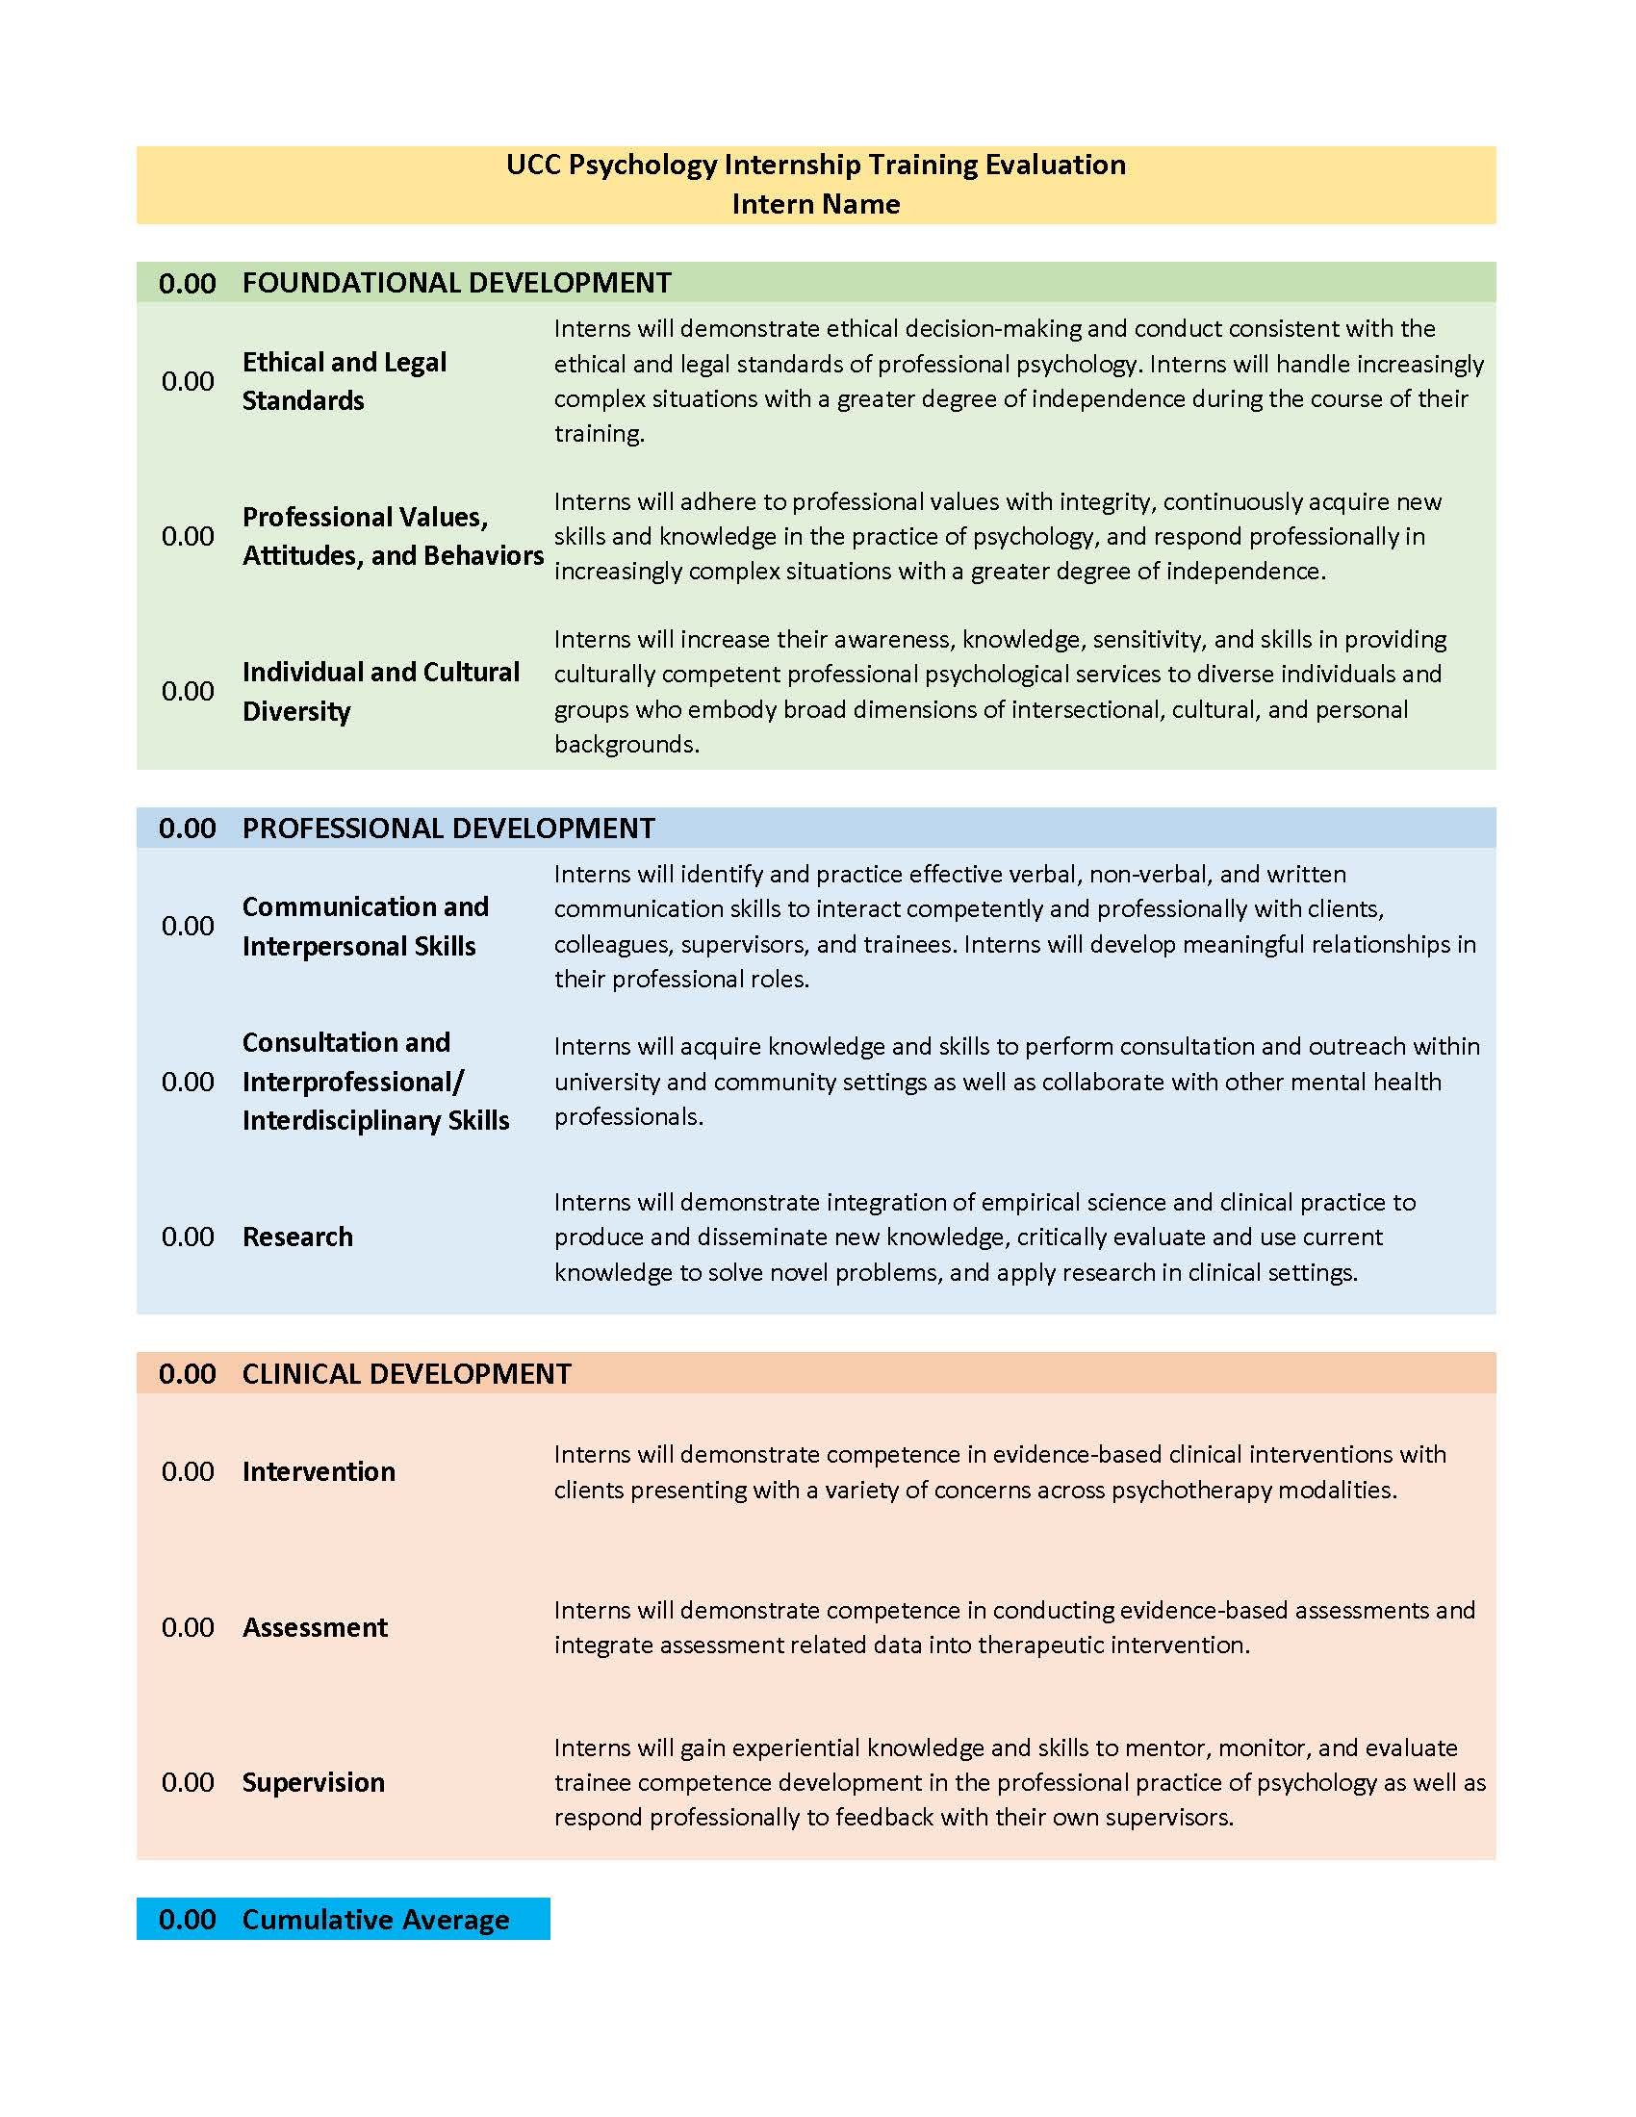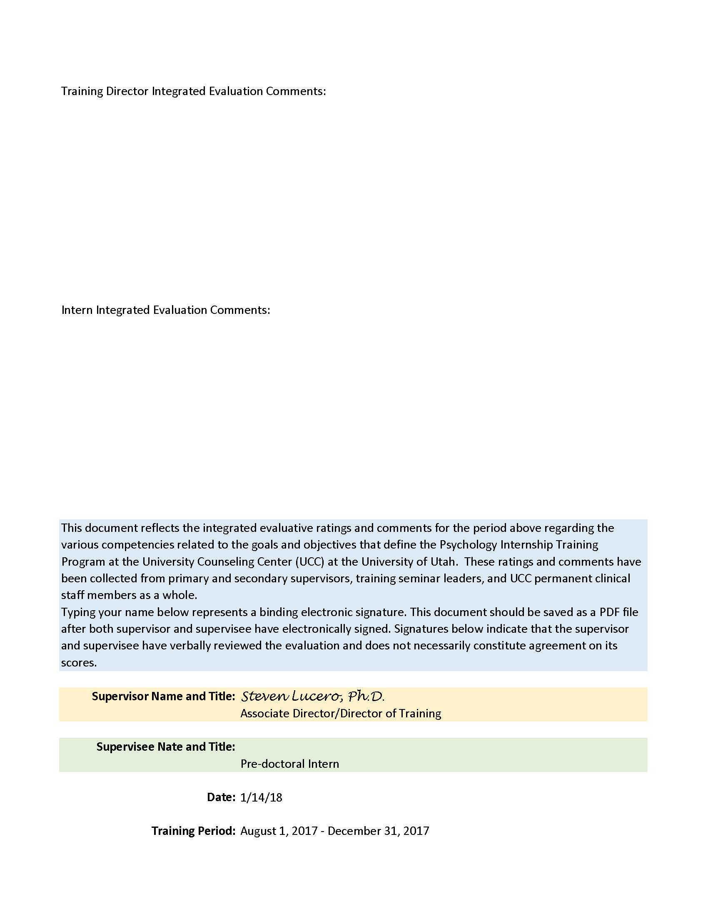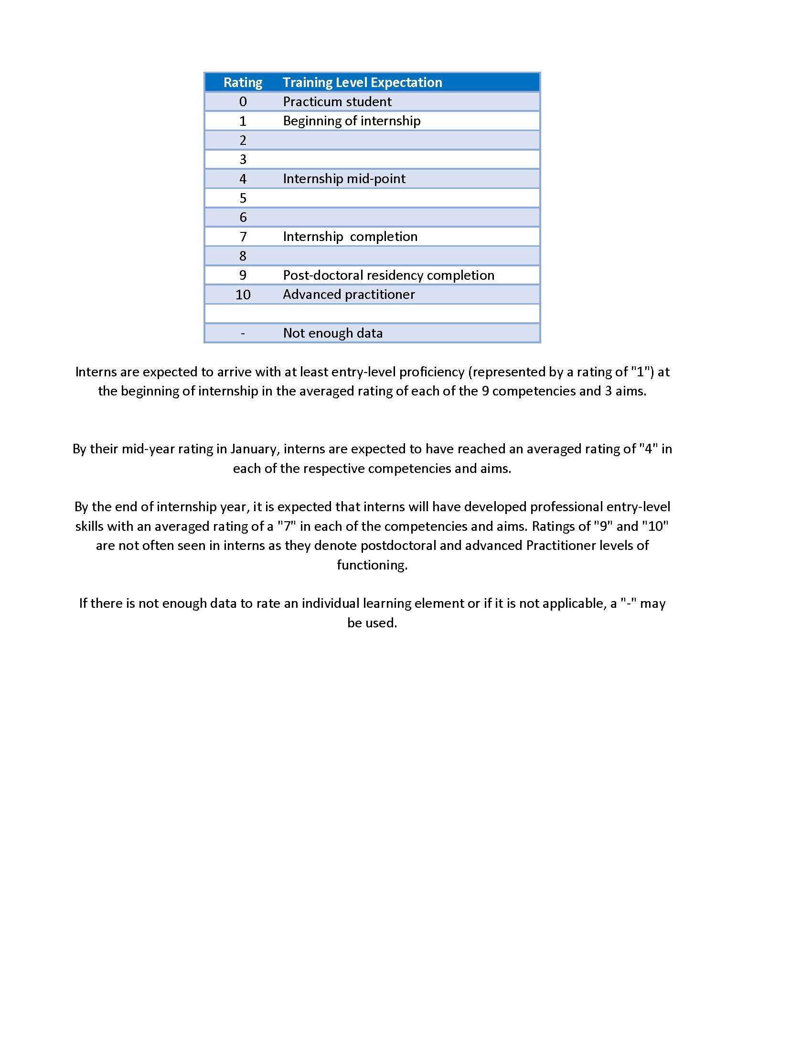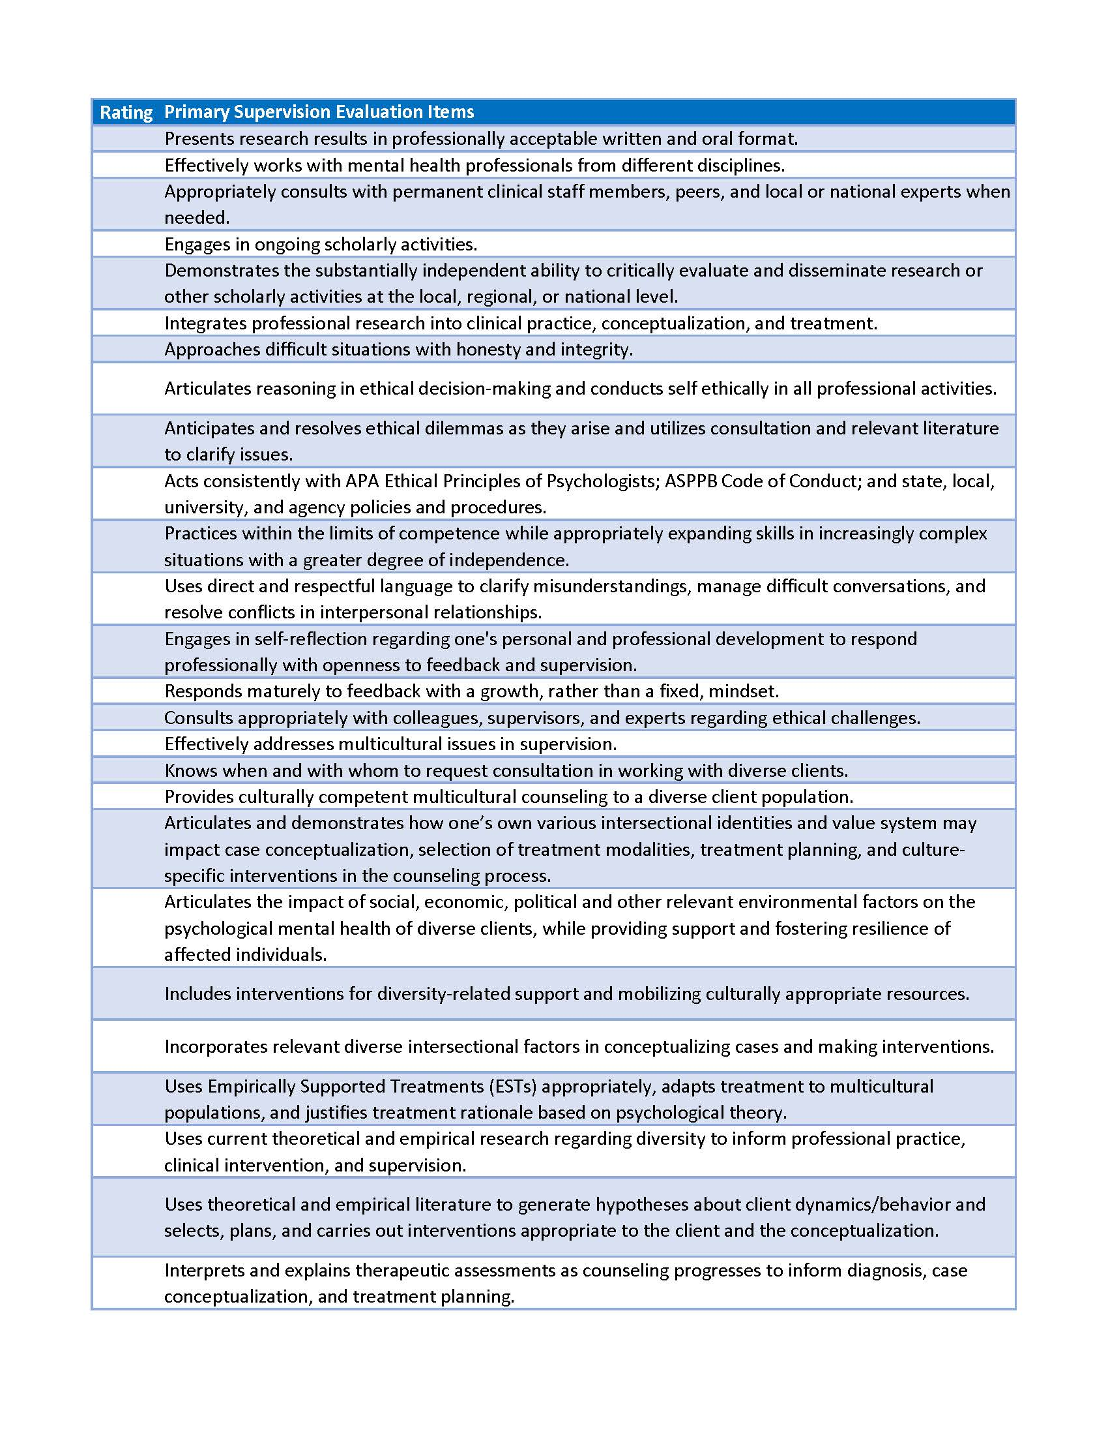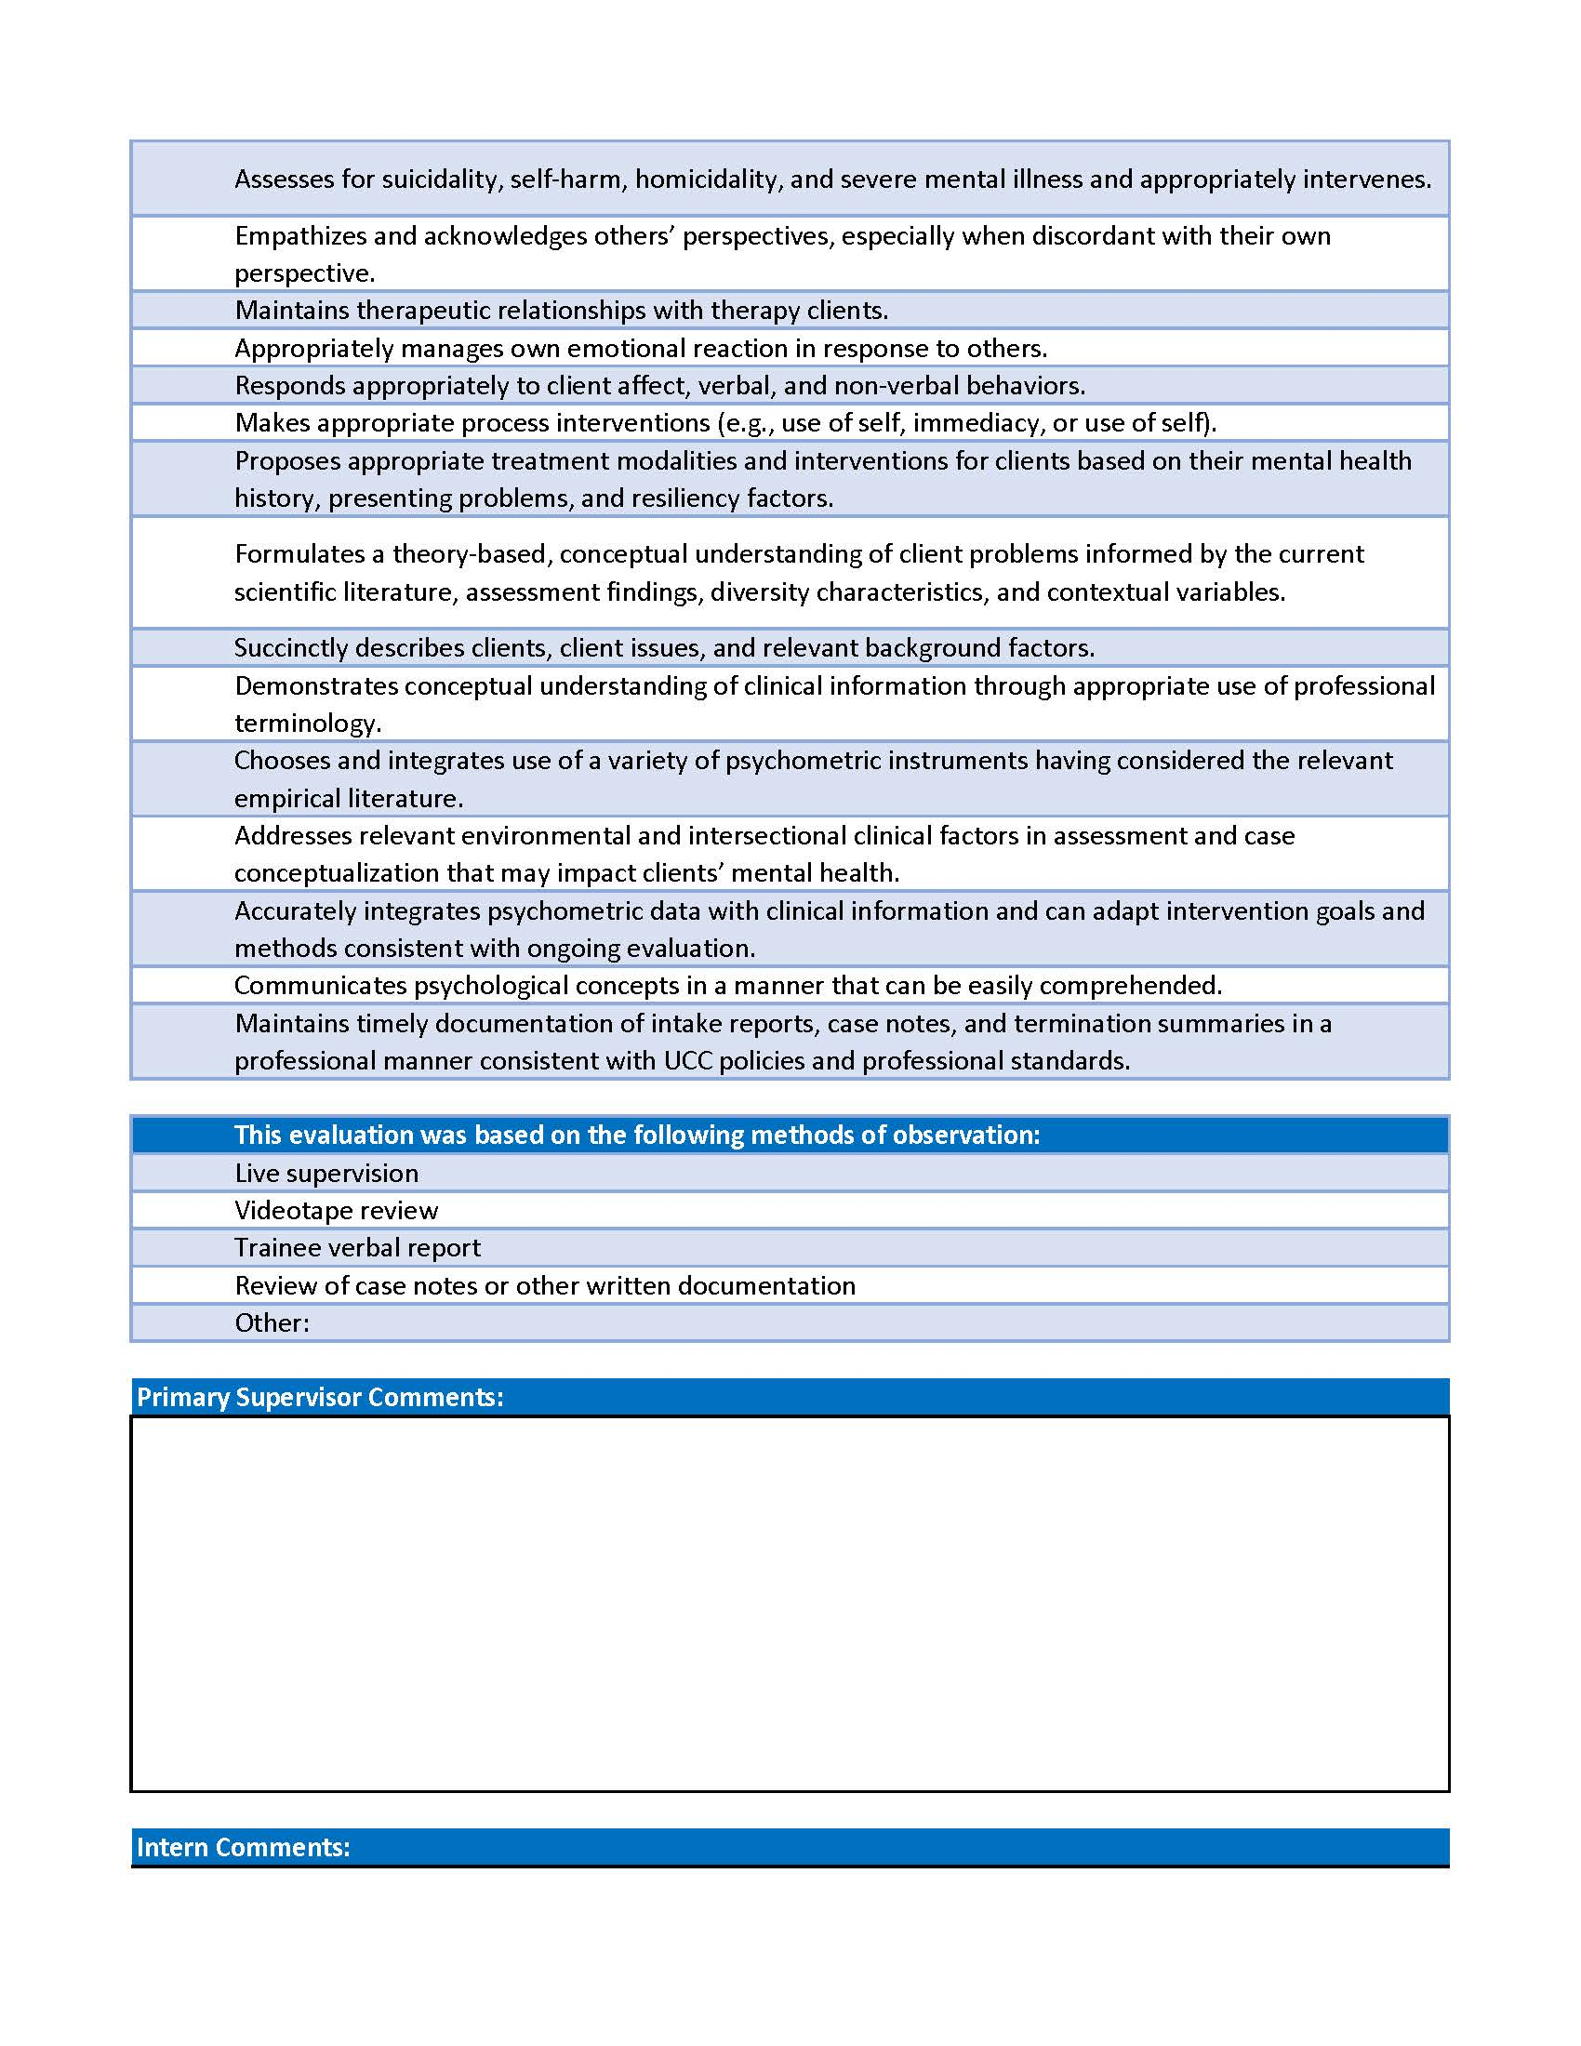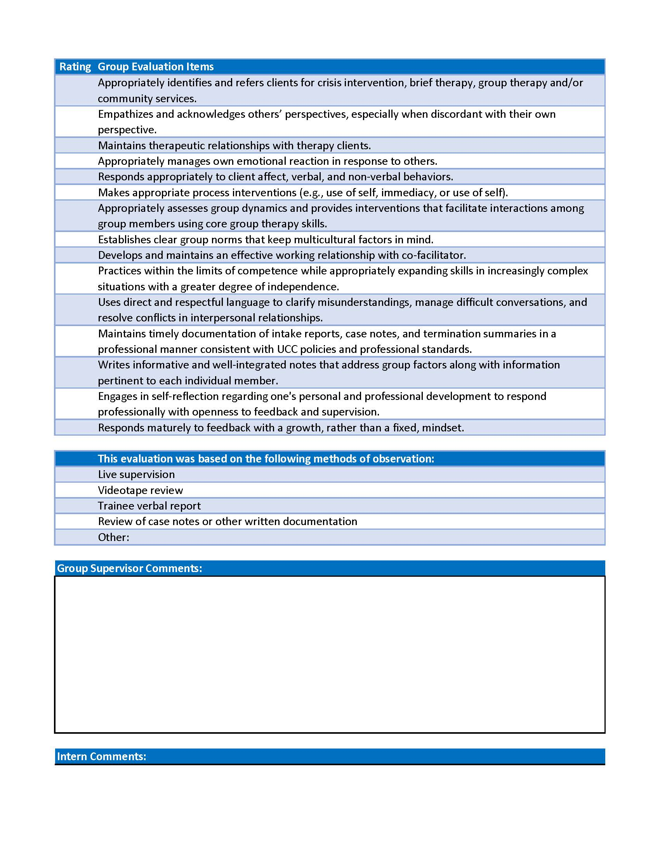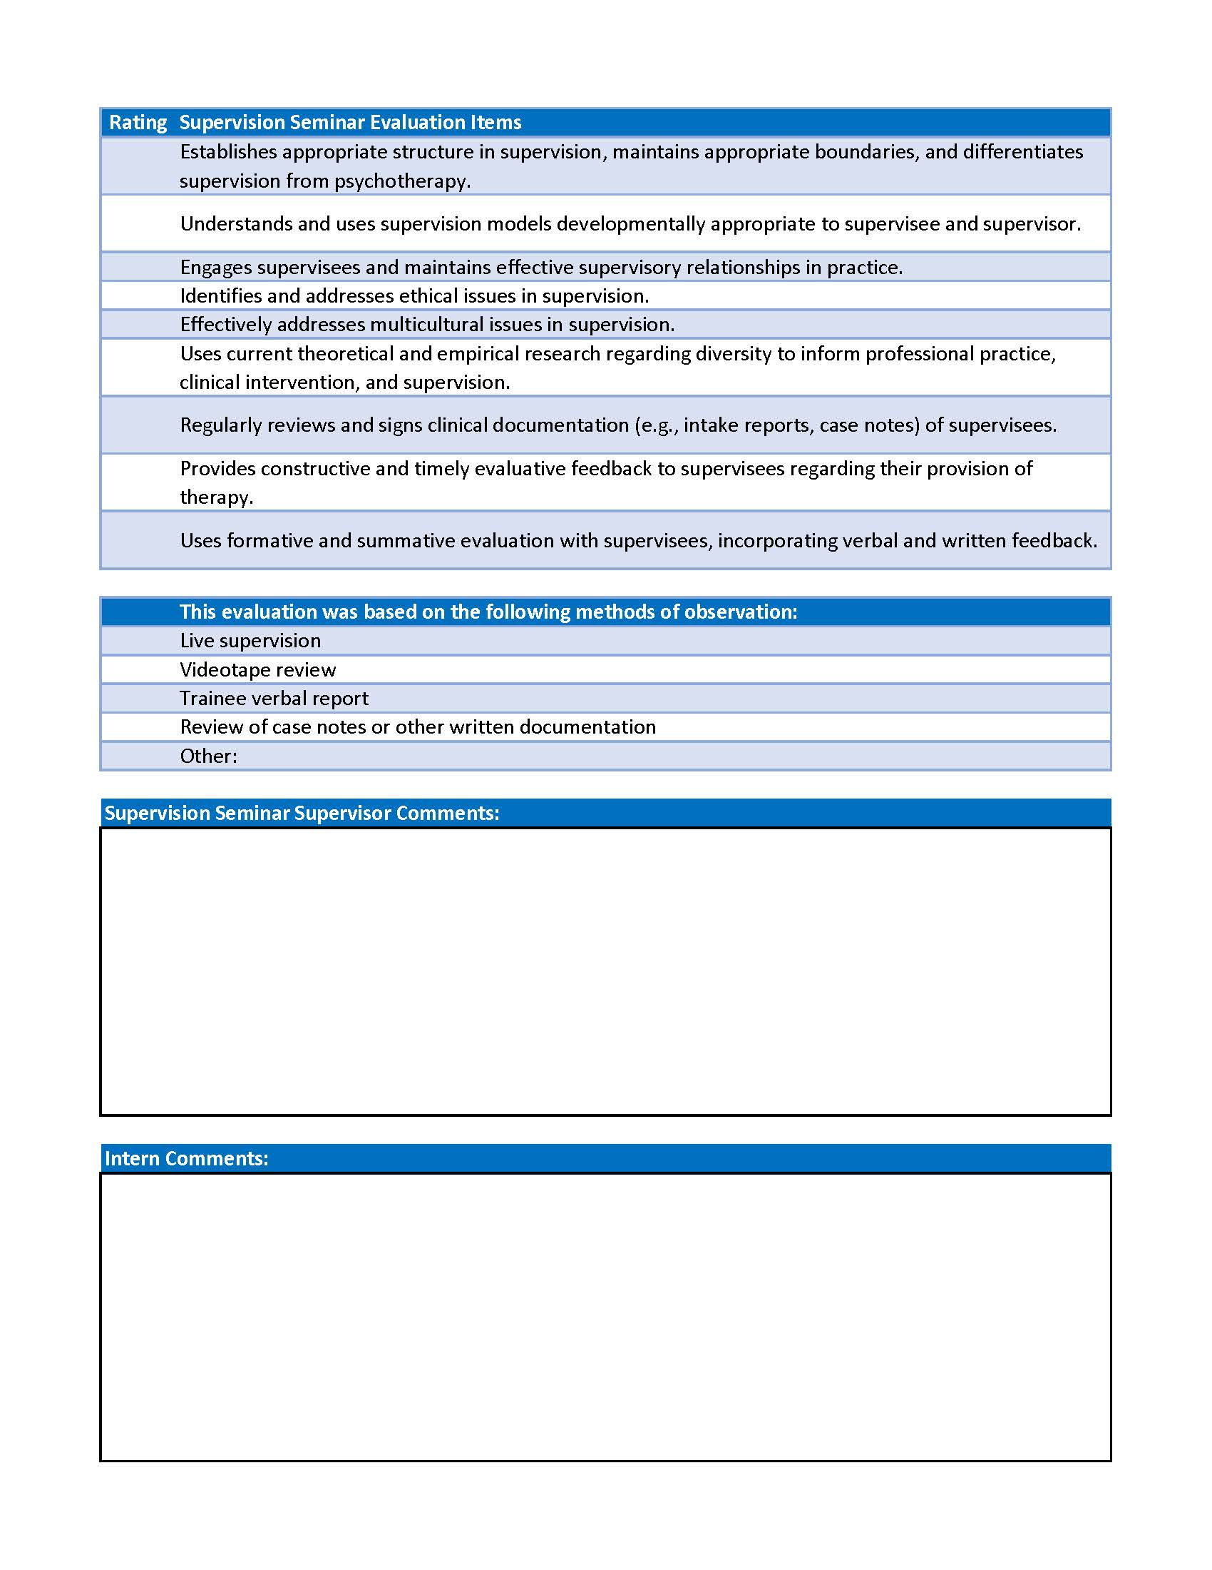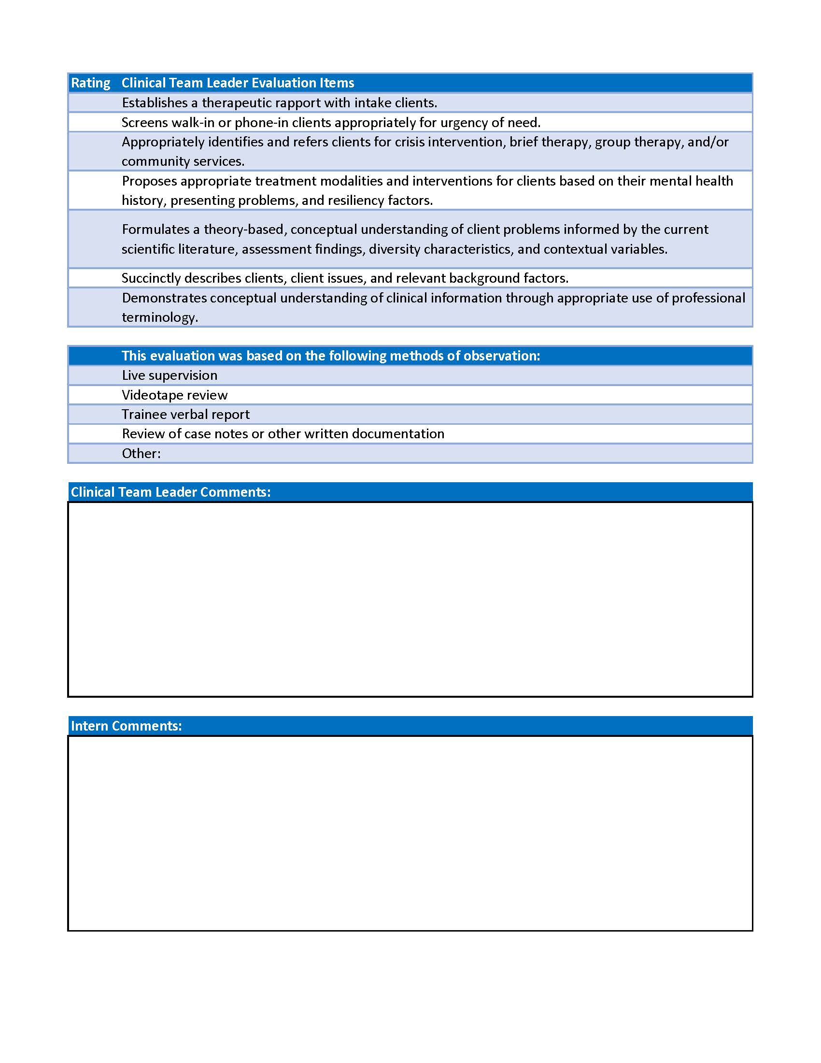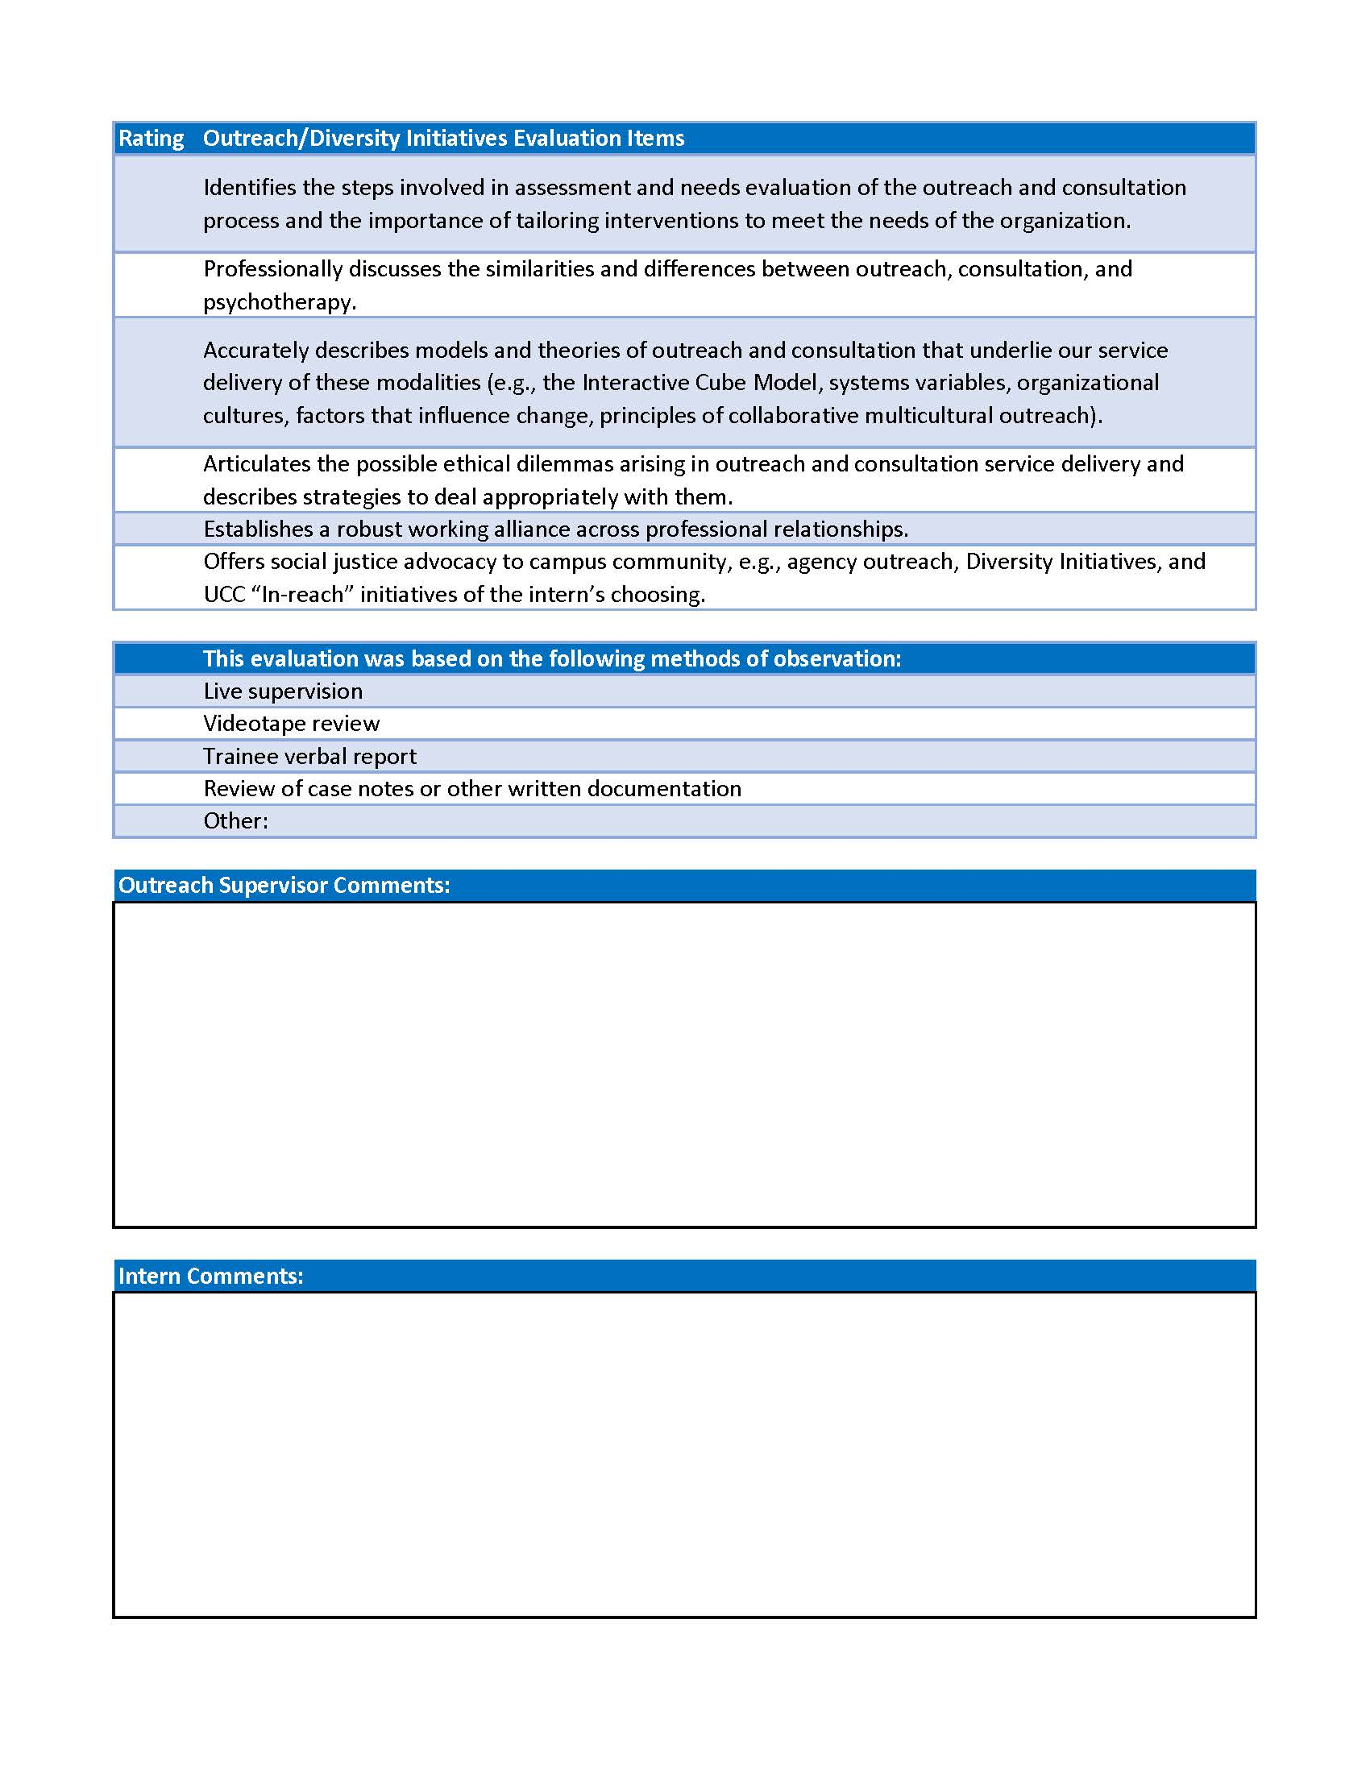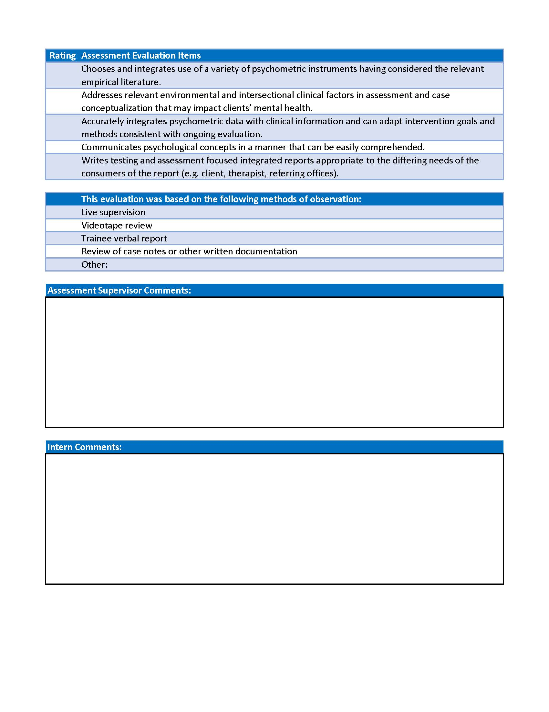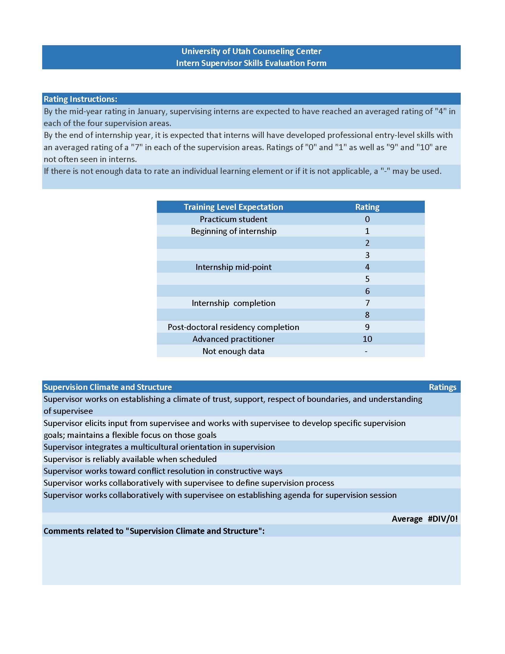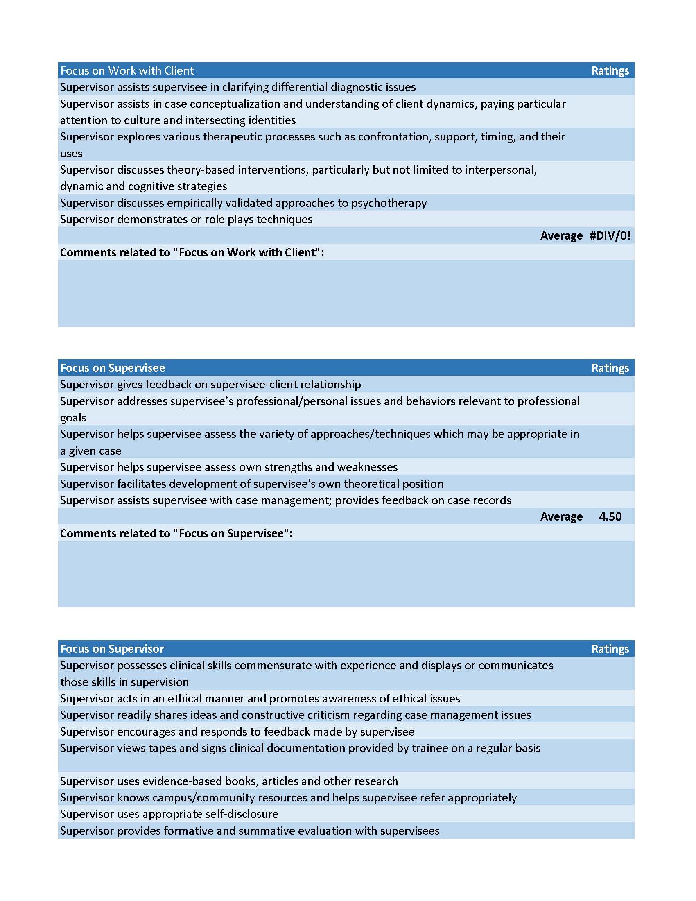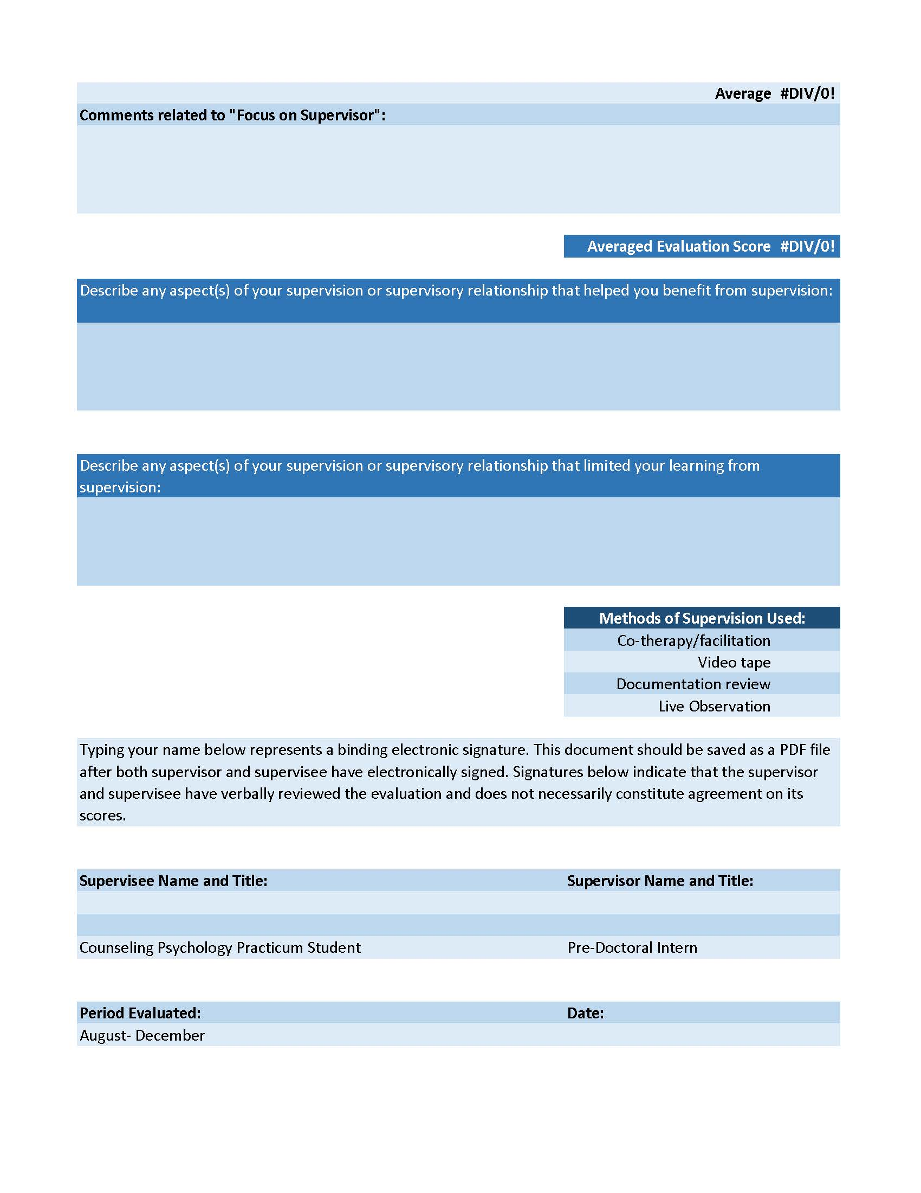

This document was developed by the Student Competence Task Force of the Council of Chairs of Training Councils (CCTC) and approved by the CCTC on March 25, 2004. Impetus for this document arose from the need, identified by a number of CCTC members, that programs in professional psychology needed to clarify for themselves and their student-trainees that the comprehensive academic evaluation of student-trainee competence includes the evaluation of intrapersonal, interpersonal, and professional development and functioning. Because this crucial aspect of academic competency had not heretofore been well addressed by the profession of psychology, CCTC approved the establishment of a "Student Competence Task Force" to examine these issues and develop proposed language. This document was developed during 2003 and 2004 by a 17-member task force comprised of representatives from the various CCTC training councils. Individuals with particular knowledge of scholarship related to the evaluation of competency as well as relevant ethical and legal expertise were represented on this task force. The initial draft of this document was developed by the task force and distributed to all of the training councils represented on CCTC. Feedback was subsequently received from multiple perspectives and constituencies (e.g., student, doctoral, internship), and incorporated into this document, which was edited a final time by the task force and distributed to the CCTC for discussion. This document was approved by consensus at the 3/25/04 meeting of the CCTC with the following clarifications: (a) training councils or programs that adopt this "model policy" do so on a voluntary basis (i.e., it is not a "mandated" policy from CCTC); (b) should a training council or program choose to adopt this "model policy" in whole or in part, an opportunity should be provided to student-trainees to consent to this policy prior to entering a training program; (c) student-trainees should know that information relevant to the evaluation of competence as specified in this document may not be privileged information between the student-trainee and the program and/or appropriate representatives of the program.
Trainee refers specifically to psychology interns, social work interns, graduate practicum students, professional counseling interns, and any other students pursuing mental health related degrees who are recruited, selected, trained, and evaluated by UCC staff with the explicit purpose of engaging in some type of clinical, outreach, or other professional service provision on behalf of the UCC.

